

**ASSIGNMENT**

**TECHNOLOGY PARK MALAYSIA**

**CT106-3-2-SNA**

**SYSTEMS AND NETWORK ADMINISTRATION**

**APD2F2506CS(CYB)**

**HAND OUT DATE: 2 Aug 2025**

**HAND IN DATE: 28 September 2025**

**WEIGHTAGE: 30%**

|  |  |  |
| --- | --- | --- |
| **No.** | **Name** | **TP Number** |
| 1. | Chew Kai Xuan | TP076457 |
| 2. | Fhang Ying Ying | TP076307 |
| 3. | Nicholas Beh | TP070075 |
| 4. | Chua Yi Hua | TP099596 |
| 5. | Julien Tan Shuen Yuen | TP075900 |

**Table of Workload Matrix**

|  |  |  |  |
| --- | --- | --- | --- |
| **No.** | **TP Number** | **Name** | **Workload Matrix** |
| 1. | TP076457 | Chew Kai Xuan | Documentation, SMTP (Postfix) Extra Features: Fail2banServer |
| 2. | TP099596 | Chua Yi Hua | DNS Installation and Configuration, Documentation (Finalise) |
| 3. | TP076307 | Fhang Ying Ying | Documentation, SMTP (Dovecot, Thunderbird), Troubleshooting |
| 4. | TP075900 | Julien Tan Shuen Yuen | Documentation, Extra Features: VPN, Lynis Audit System |
| 5. | TP070075 | Nicholas Beh | Documentation, Web Server (Apache, SSL/TLS), Troubleshooting |

**Table of Contents**

1.0 Introduction 3

2.0 DNS Server 4

3.0 Email Server 17

3.1 Postfix 18

3.1.1 Installation 18

3.1.2 Configuration 18

3.2 Dovecot 20

3.2.1 Installation 21

3.2.2 Configurations 21

3.2.3 Troubleshooting 25

3.3 Mail System Testing on Mutt (CLI) on Server (Rocky) 26

3.3.1 Installation 27

3.3.2 Configuration 27

3.3.3 Testing on Mutt 27

3.3.4 Troubleshooting 29

3.4 SSL Configuration 30

3.4.1 OpenSSL Installation 31

3.4.2 Postfix 31

3.4.3 Dovecot 32

3.4.4 Testing SSL on Rocky Server 33

3.4.5 Testing SSL on Ubuntu Client 34

3.5 Thunderbird 35

3.5.1 Installation 35

3.5.2 Account Setup 36

3.5.3 Import SSL Certificate 38

3.5.4 Update Configuration Settings 39

3.5.5 Testing with Thunderbird 40

4.0 Web Server 44

4.1 Apache Web Server 45

4.2 Installation and Configuration SSL on Apache 49

5.0 Extra Service 52

5.1 Fail2ban 53

5.2 VPN Setup 56

5.3 Lynis Audit System 60

6.0 Troubleshooting 63

6.1 SMTP 64

6.2 Apache Web Server 71

7.0 Conclusion 74

8.0 Group Photo 75

9.0 References 77

# 1.0 Introduction

As part of this assignment, we were assigned the task of designing and implementing a functional network environment using rocky Linux as the server and Ubuntu Linux as the client in virtual box. This was aimed at integrating several key services, namely DNS, DHCP, Email, Web, and SSL/TLS, to come up with a functional system that can be included in an actual organizational structure.

This configuration reflects the needs of present-day businesses, where the domain name resolution can be trusted, the distribution of IP addresses should be automated, the communication is to be secure, and the web is to be opened. Implementing these services in Linux provided us with technical knowledge of server setup in addition to learning how to troubleshoot, secure, and document a production-like system.

**Our Configuration**

**Rocky Linux (server):** snaAlpacaserver.llama.com

**Ubuntu (client):** snaAlpacaclient.llama.com

**Network:** 10.20.30.0/24

**DNS (Domain Name System)**

Domain Name System (DNS) has one of the most basic services within any network. It is primarily utilized to convert human readable domain names into IP addresses that can be read by a machine. In this case, when a customer enters the name **(snaAlpacaclient.llama)**, DNS will provide the appropriate IP address of the Rocky Linux server where it serves.

During our assignment, we had to configure DNS using the Berkeley Internet Name Domain (BIND) on the Rocky server. We set a forward zone in our group domain。

**DHCP (Dynamic Host Configuration Protocol)**

Dynamic Host Configuration Protocol (DHCP) is a protocol that is employed to automatically allocate devices within a network with IP addresses and other network configuration information (subnet mask, default gateway, and DNS servers). This saves the time of manually configuring all the devices.

Functions of DHCP:

1. Dynamic IP assignment of devices to a network.
2. Less configuration errors as the process are automated.
3. It guarantees effective reuse of the IP addresses by way of a lease system.

# 2.0 DNS Server

Fully Qualified Domain Name (FQDN)

* snaAlpaca.llama.com
* snaAlpacaserver.llama.com
* snaAlpacaclient.llama.com
* IPv4 Prefix: 100.200.300.0/24

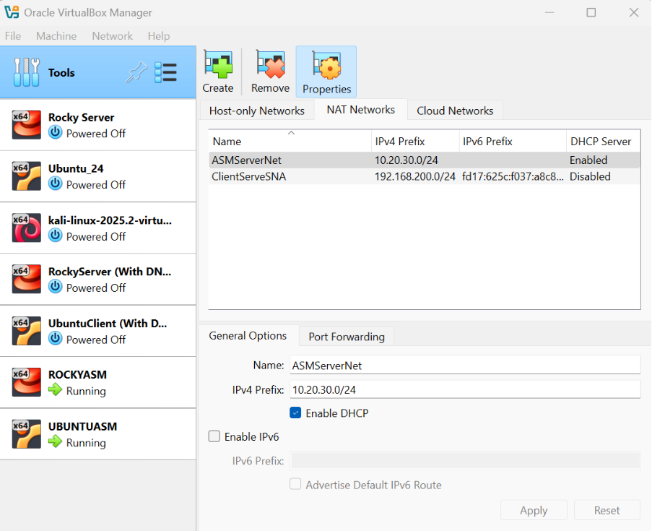

Rocky IP Address: 10.20.30.5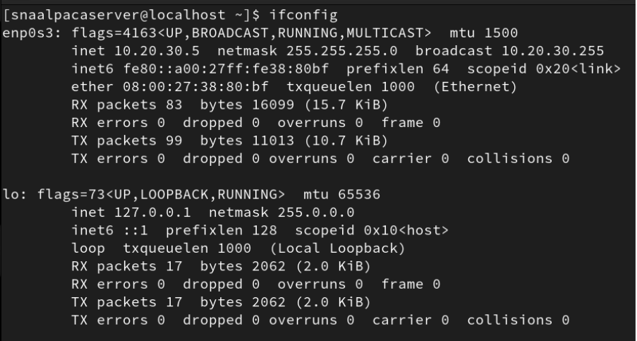

Ubuntu IP Address: 10.20.30.4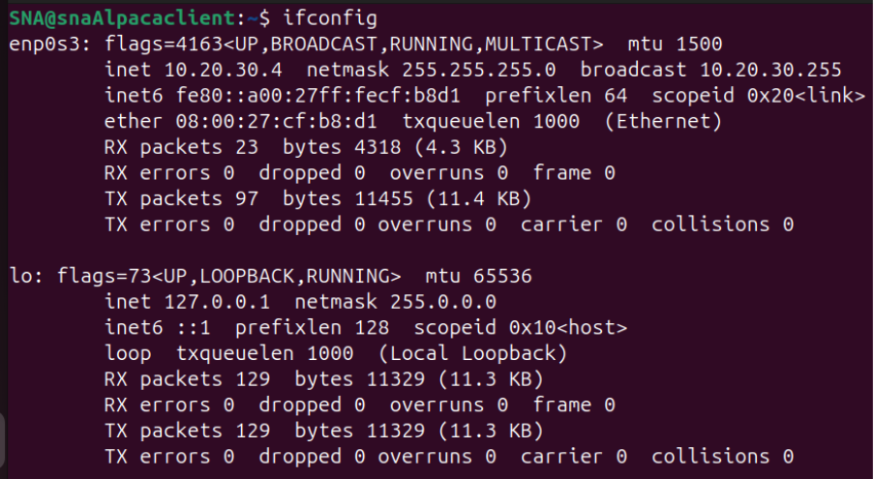

Rocky – Hostname & Hosts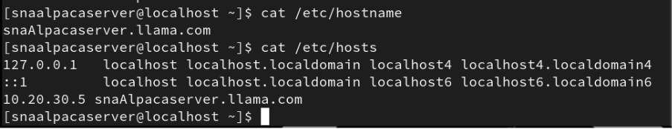

Ubuntu – Hostname 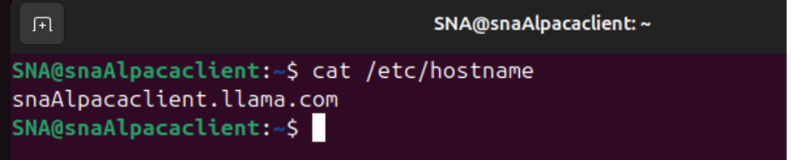

Rocky – Network Manager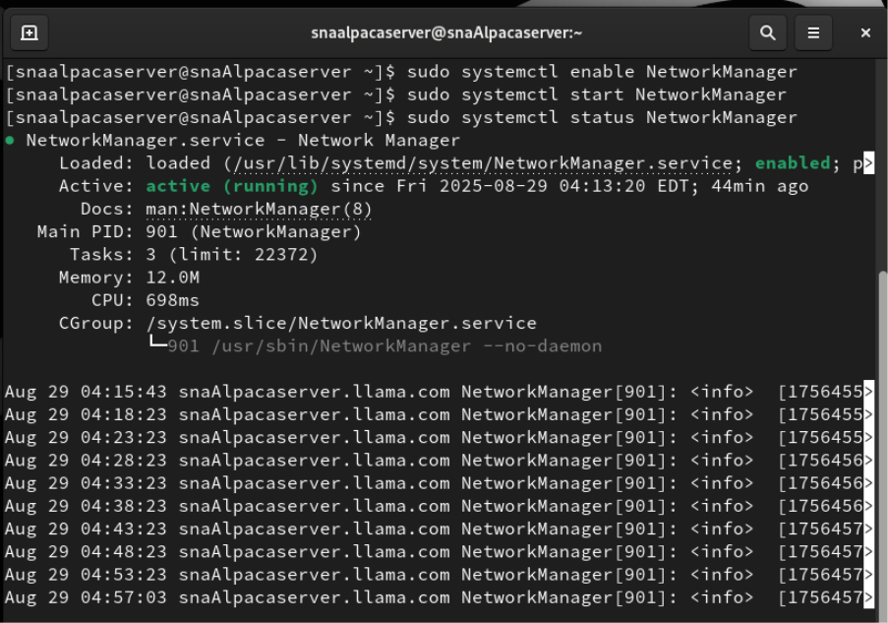

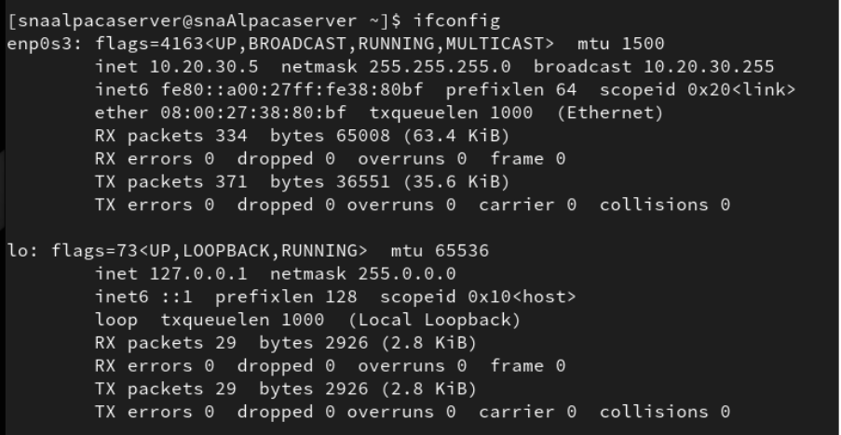

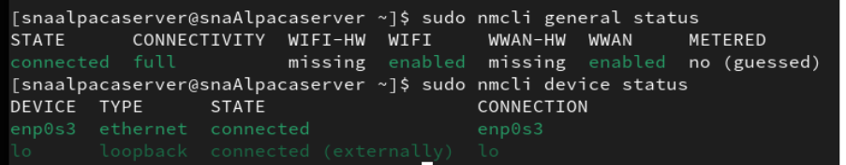

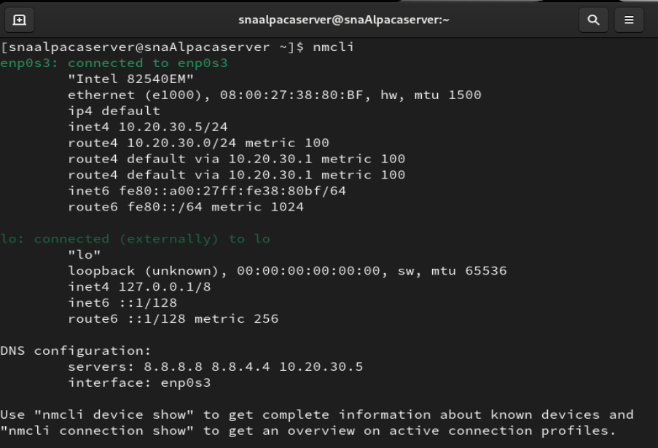

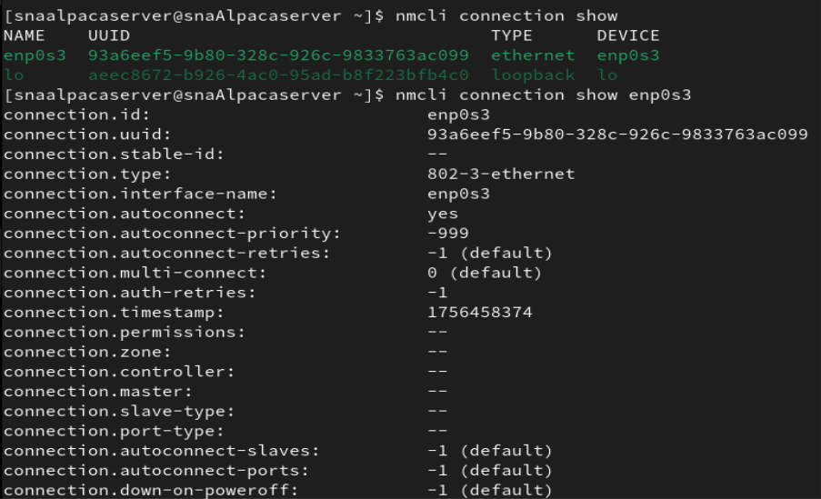

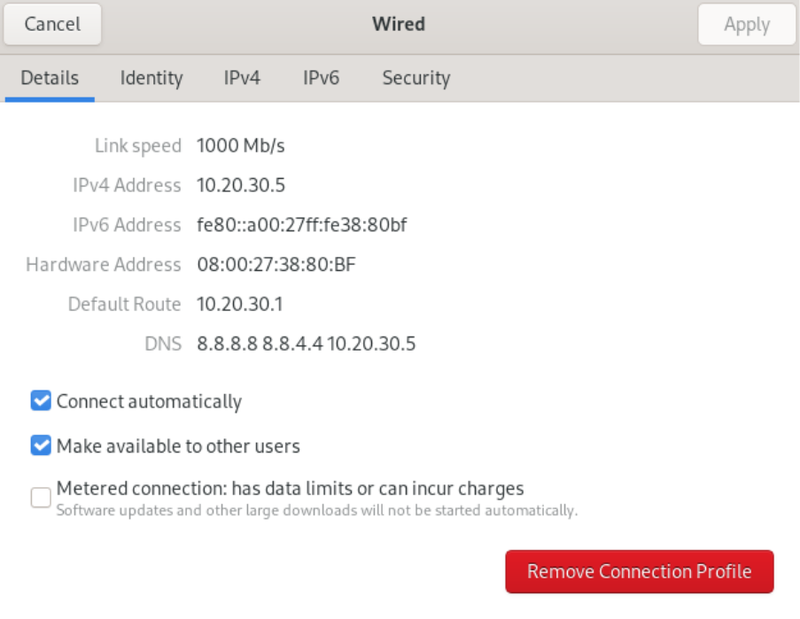

Ubuntu - Network Manager

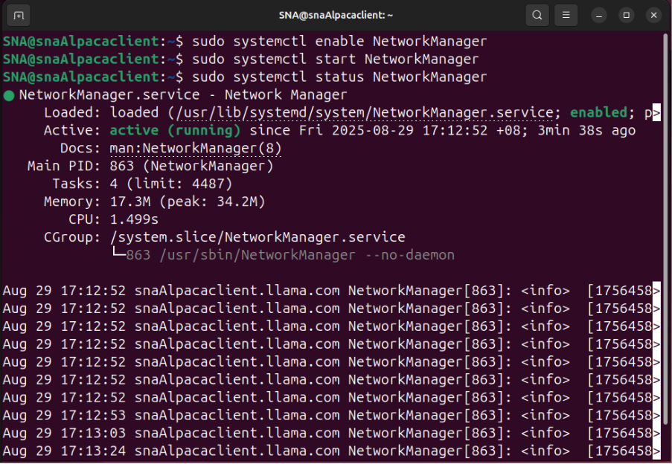

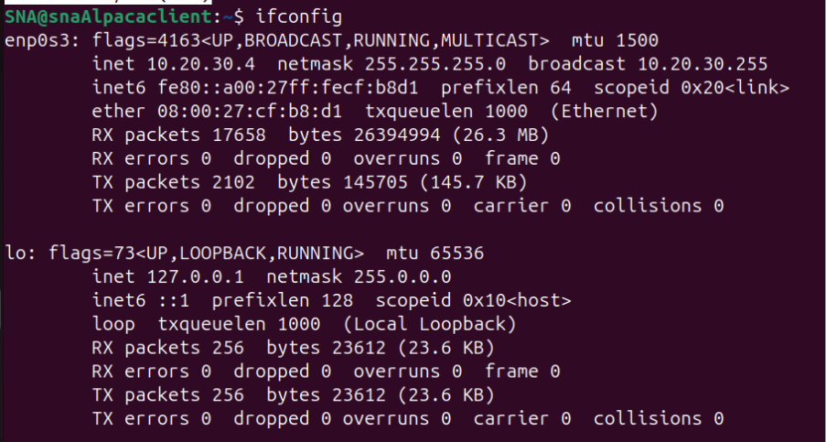

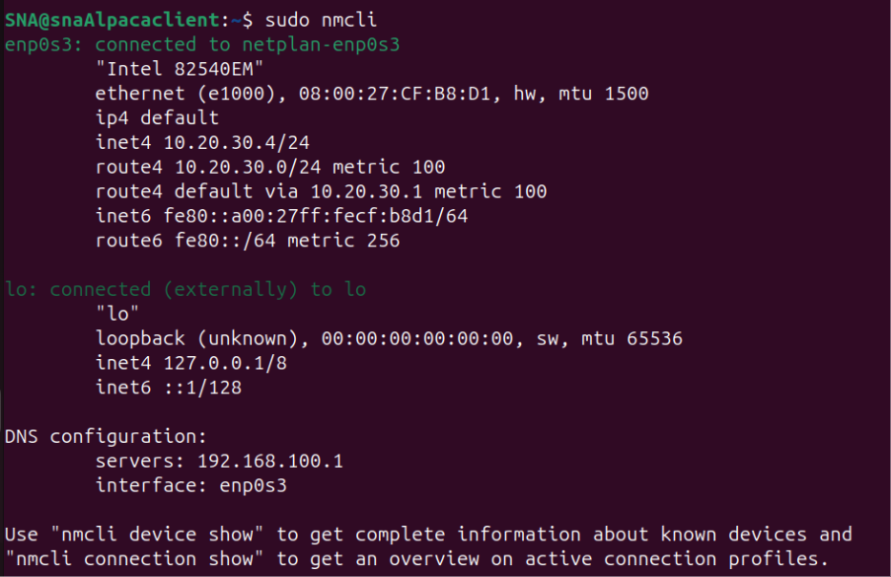

Rocky – DNS Configuration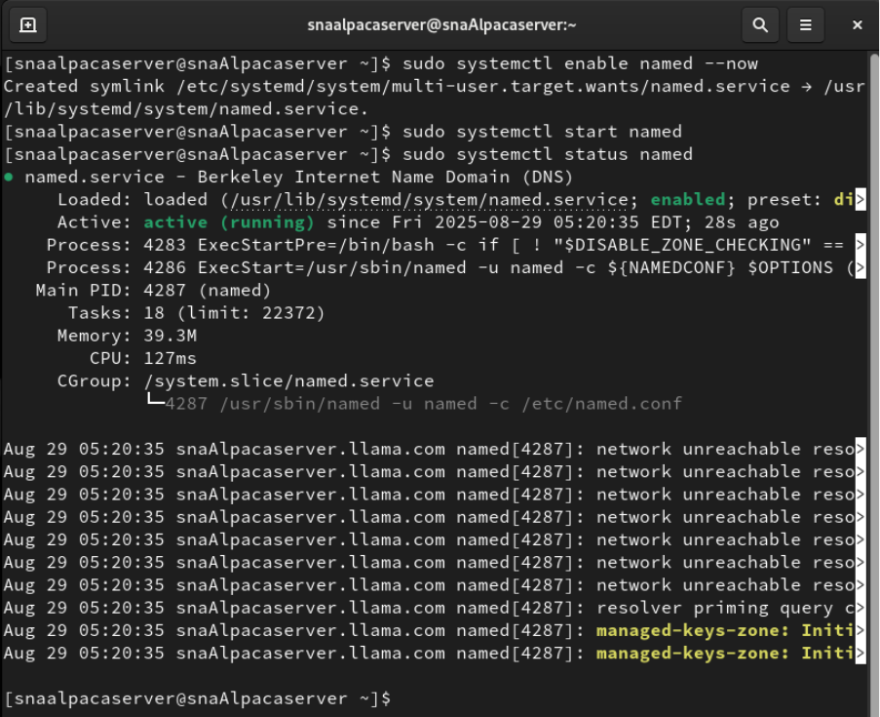

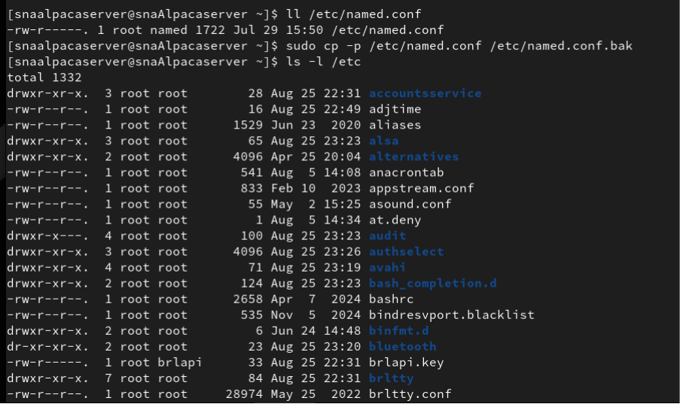

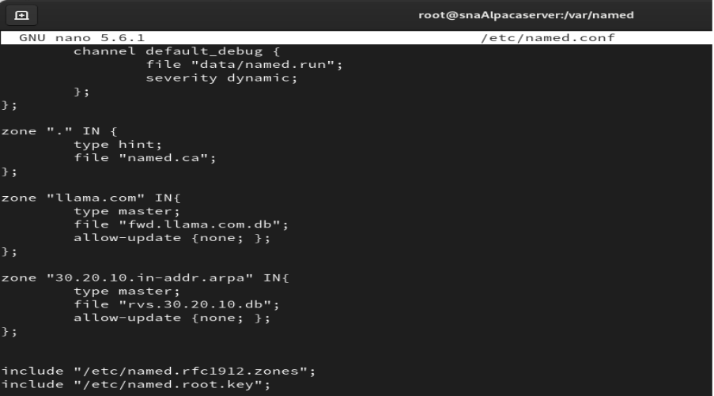

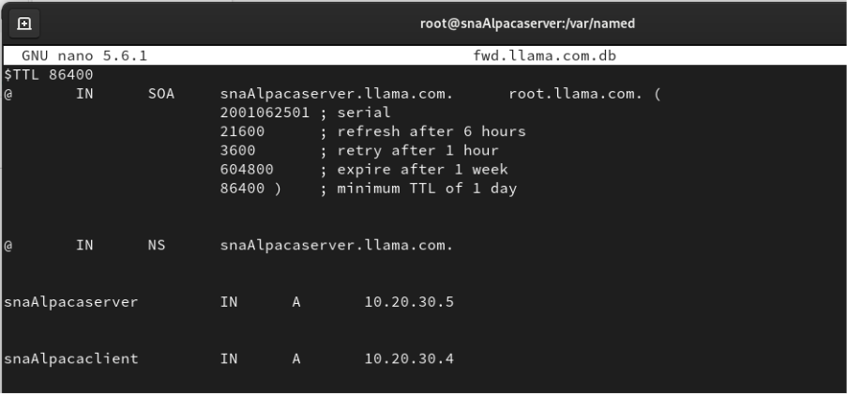

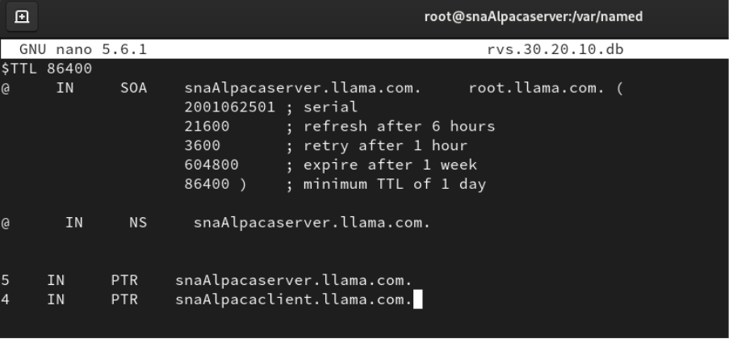

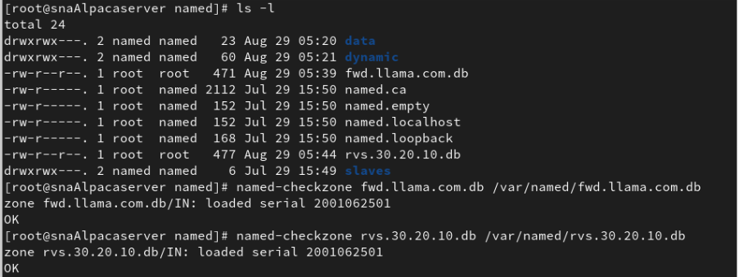

Ubuntu – DNS Configuration

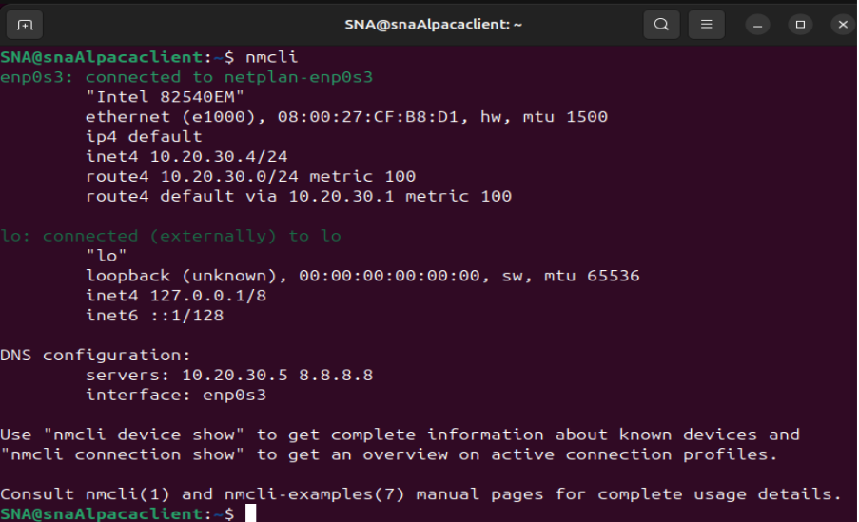

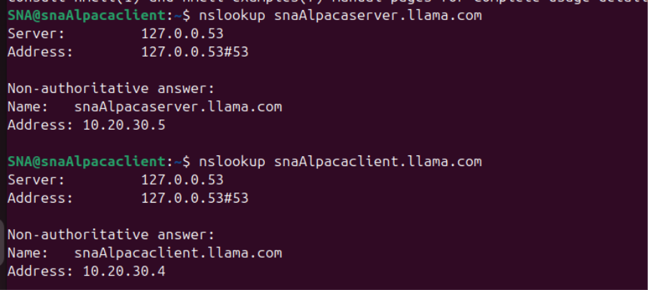

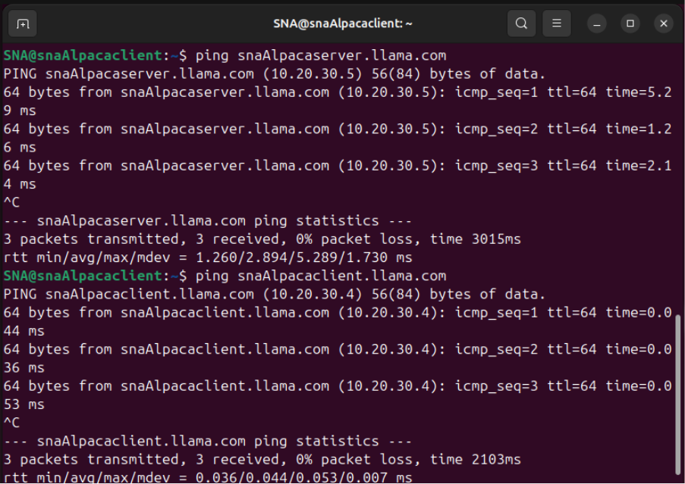

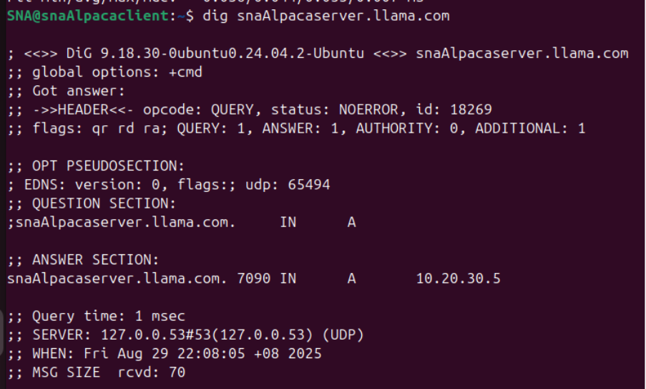

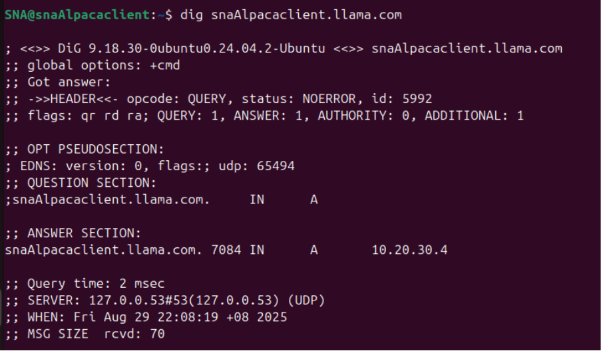

# 3.0 Email Server

## 3.1 Postfix

Postfix is an open-source and free mail transfer agent (MTA) that is used on Unix-like systems to send and receive email. It becomes the intermediary, which receives emails form clients or applications, processes them and then relays them on to another mail server or a local mailbox. Postfix is very popular since it is a fast and secure SMTP with a simple configuration, commonly used as the foundation of configuring internal or external mail server. It is also capable of being integrated with other services such as dovecot (to support IMAP/POP3) to form an all-embracing email solution.

### **3.1.1 Installation**

Install Postfix. 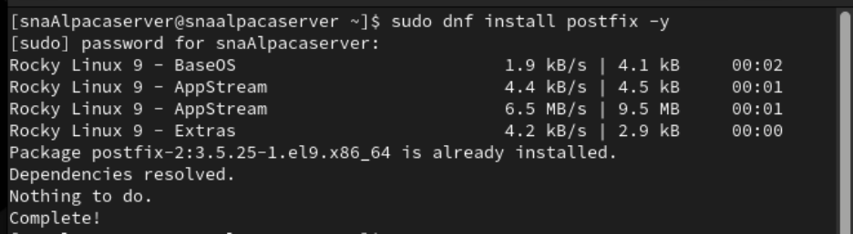

Verify through listing files, it’s located within the **etc/postfix** directory.

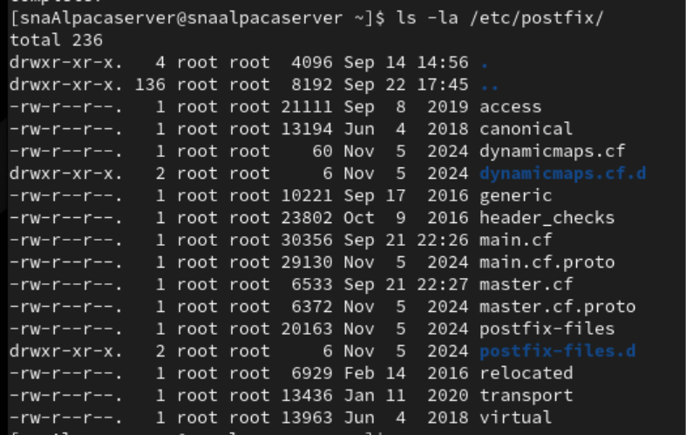

### **3.1.2 Configuration**

Setting up our machines’ identity and credentials, we make modifications to main.cf file. We also establish restrictions and policies for Postfix.

1. **main.cf**

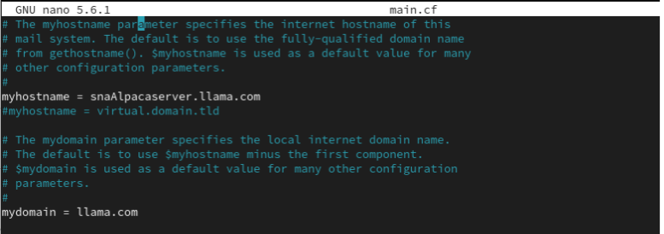

Defining hostname and domain name. Set up server’s identity for the service.

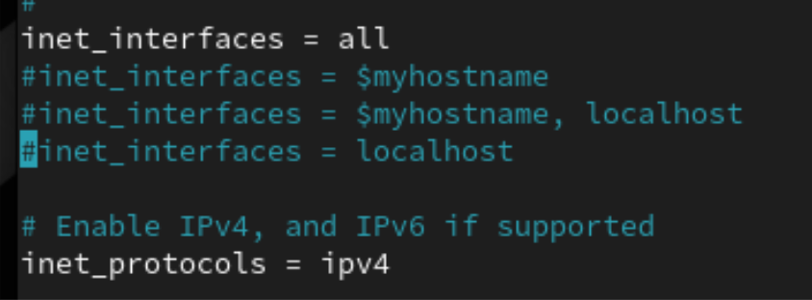

Network interfaces Postfix will enable the protocols. Defining the client then connecting to server.



Enable Postfix as local domain. Recognize them as local destinations to deliver mail.

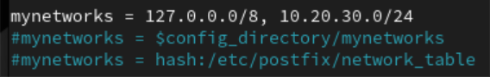

Postfix unable define local domains. 127.0.0.0 is loopback range, 10.20.30.0/24 consists of IP addresses from 10.20.30.0 to 10.20.30.255.

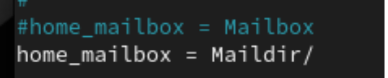

Define directory - Maildir to store emails.



Greeting banner - User connects to SMTP port and we verify the connection on our client machine (Ubuntu).

Example output: **220 snaalpacaserver.llama.com ESMTP**

**Additional Configurations**

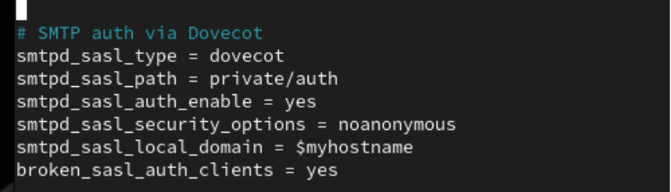

SMTP Authentication via Dovecot. Dovecot is used to authenticate SMTP service through communicating with Postfix.

**TLS and SSL Configuration for SMTP**

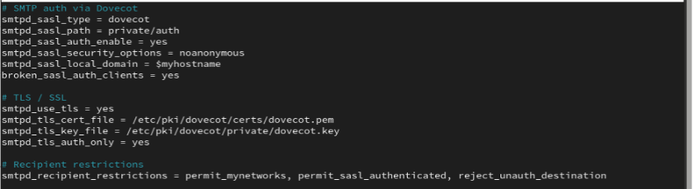We modify SSL certificate and private key directory. We enabled service, defined certificates with private key locations and added restrictions.

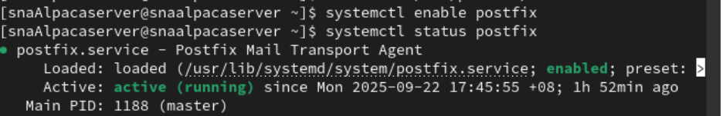

We enable the service and check with status.

## 3.2 Dovecot

Dovecot is a free open-source IMAP and POP3 server which is used with a mail transfer agent such as postfix to allow users to access their email. Whereas Postfix deals with the transfer of mail between servers, receiving and sending, dovecot is the storage volume which holds the messages safely and adds them to the users on their log in to their email client (Thunderbird). It has the reputation of being lightweight, secure, and easy to set up with such features as authentication, mailbox indexing, and encryption to offer a trusted service of email retrieval.

### **3.2.1 Installation**

Install Dovecot. Using **sudo dnf install dovecot –y** command.

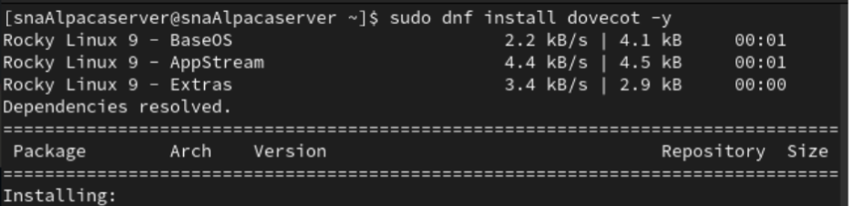

Using command cd /etc/dovecot/ to verify the installation. Then use ls command to list all files in it.



### **3.2.2 Configurations**

1. **Dovecot.conf**

Dovecot listens to all existing IPv4 addresses.

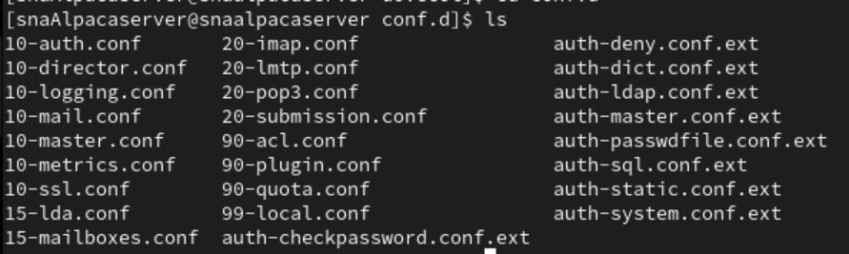

Essential Files for Configuration

1. **10-auth.conf**

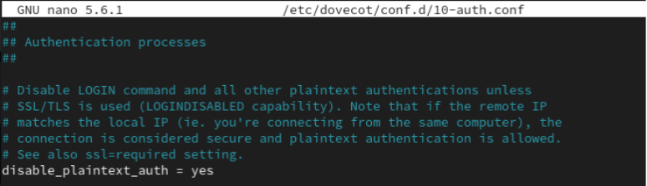

Log in is encrypted. Dovecot does not allow plaintext authentication and reduces the possibility of eavesdropping.

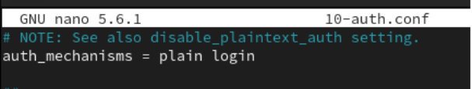

Allowing authentication mechanisms - plain and login.

1. **10-mail.conf:**

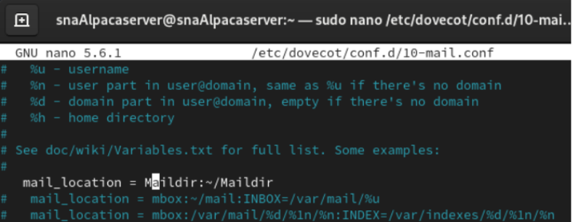

Configuring Dovecot to store users’ mails in the Maildir directory.



Gaining permission of read and access the mail to all users.

1. **10-master.conf**

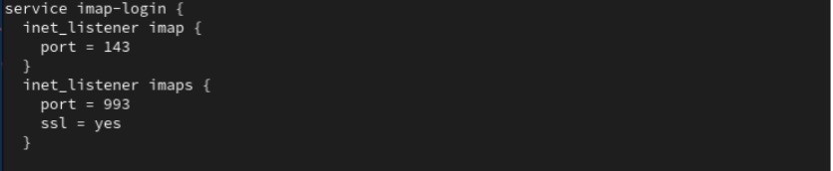We use IMAP configuration standard (143) and IMAPS configuration (SSL/TLS) support. All data is transferred in plain text with optional STARTTLS in Standard IMAP, and the whole connection is encrypted in IMAPS, making it more secure.

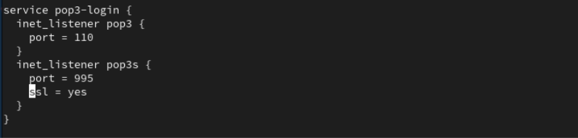pop3 login: Clients connect through standard protocol or encrypted protocol: pop3s.

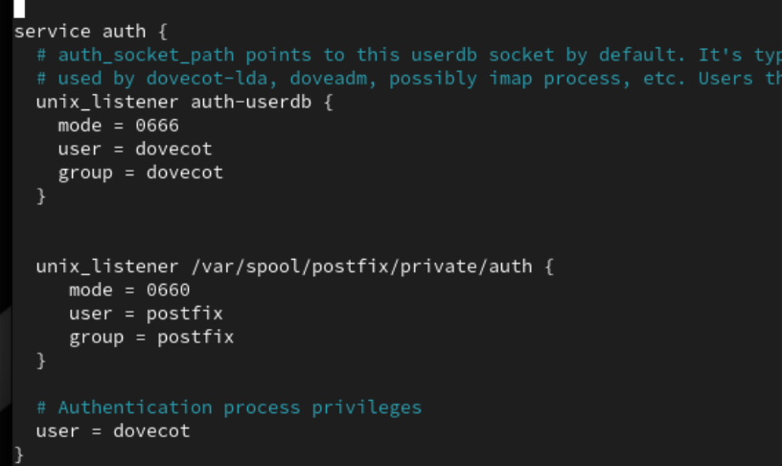

Dovecot managing login requests.

1. **10-ssl.conf**

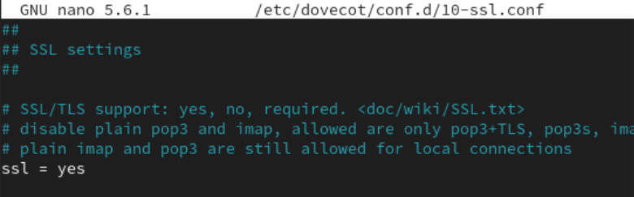Enables SSL encryption for all existing services running on Dovecot.



Ensures Dovecot services only support TLS encryption versions.

**Additional Configurations**

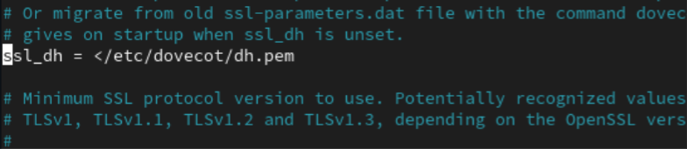Prevent third parties from decrypting past emails.

We generate a Diffie-Hellman parameter file that we enabled in our **10-ssl.conf** file.



We set the permission of file to 600 with reading/writing access by the owner only.

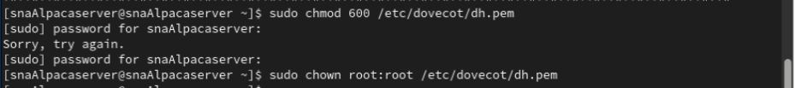

Restart service and verify service status. 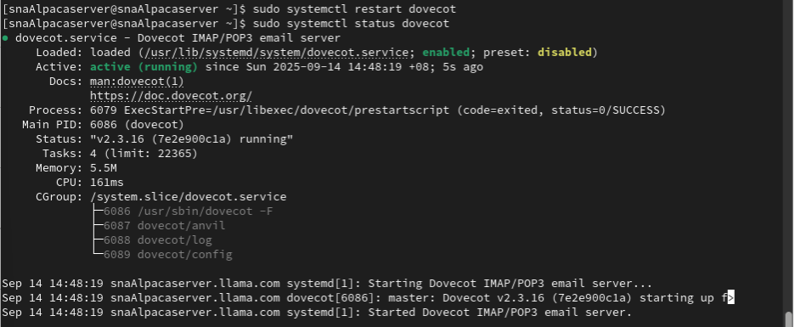

We have the firewall enabled on POP3 and IMAP.



Restart Dovecot.

### **3.2.3 Troubleshooting**

Error: Unable to restart (Dovecot)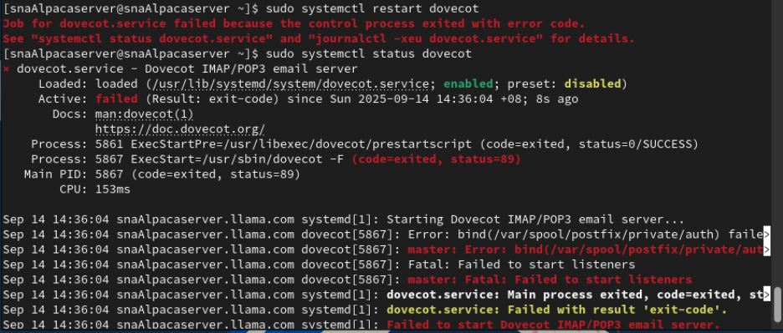

**Solution**

Step 1: Disable SELinux temporarily, since it’s a factor of Dovecot startup failure in Rocky systems.

Step 2: Configure rules, postfix_var_run_t onto files under “/var/spool/private(/.*)?”. SELinux can identify them as the files of Postfix socket files. Dovecot can access files and communicate with Postfix for authentication.

Step 3: Re-enable SELinux for changes.

Step 4: Restart the service.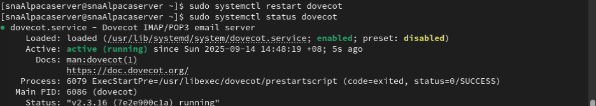**Explanation:** If Dovecot unable to interact with Postfix, the service might not start. One of the causes is SELinux has denied access to Postfix socket files and required to authenticate.

## 3.3 Mail System Testing on Mutt (CLI) on Server (Rocky)

Mutt is a lightweight text-based email application, which is used on Linux and Unix operating systems. It is a terminal-based application and is fast, flexible, and efficient in processing large amounts of emails. Mutt also provides compatibility with newer services such as IMAP, POP3, SMTP, and Maildir, and can be used in conjunction with other tools (such as encryption) such as GPG/PGP and S/MIME. Though lacking a graphical interface, its power has a strong customization, scripting ability, and is best suited to system administrators or users who like command-line applications.

### **3.3.1 Installation**

Installing Mutt for testing purposes before setting up Thunderbird on client machine.

### **3.3.2 Configuration**

Create a new user for testing purposes.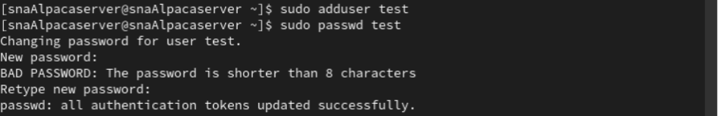

Create a **Maildir** directory in the user’s home directory with three subfolders: **cur** (read emails), **new** (unread emails), and **tmp** (emails pending delivery).

Test User Access:

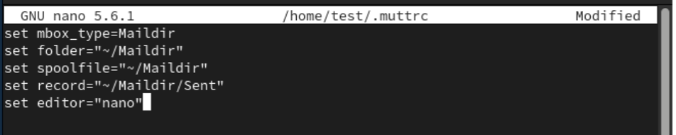Set up the configuration file for Mutt. Define how Mutt will work with the mailbox format, directories and editor format.

### **3.3.3 Testing on Mutt**

With command mutt, we start email client on terminal.

Running Mutt, accessing and managing mail. To compose new mail, we clicked ‘M’.

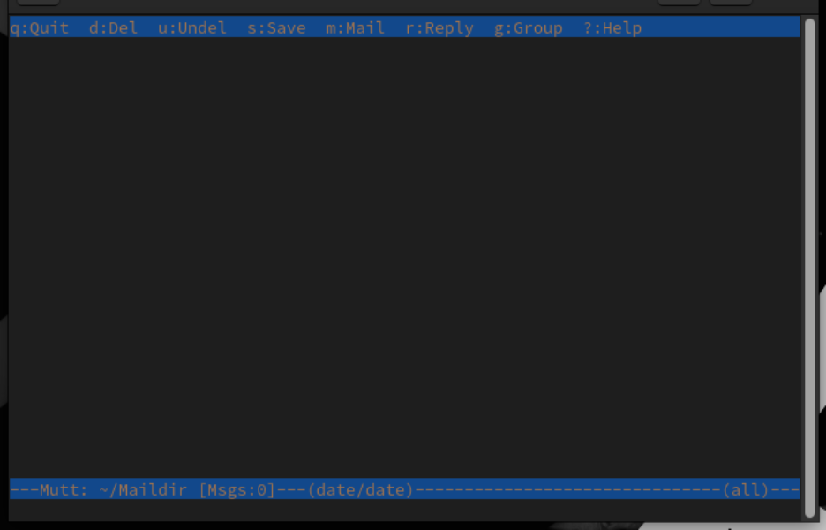

Input username to deliver the mail to bottom left of terminal. Sending the mail to new user created. By clicking ‘Enter’, enter the subject of mail. Then, click ‘Enter’ again to start developing the mail body.

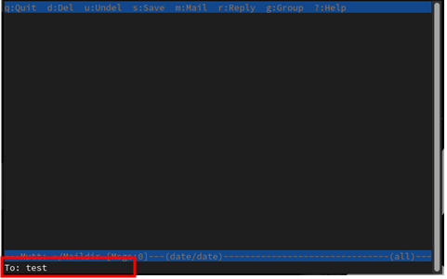



Input email body and click Ctrl+O to save changes, then exit to deliver mail.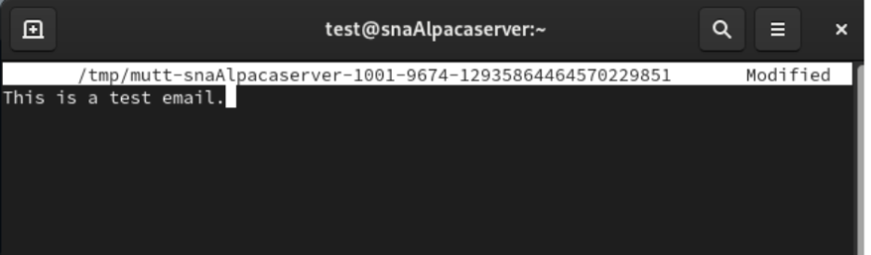

Click ‘Y’ to send mail. The notification will appear at the bottom of the terminal to indicate that it has been delivered successfully.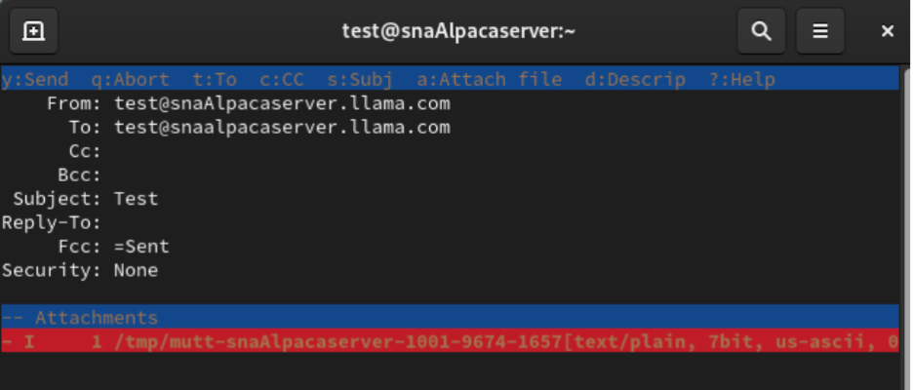

Directed back to dashboard of Mutt, we can see the mail - ‘Test’ (Record 3), has been delivered successfully. By clicking ‘Enter’, we can see the content of mail.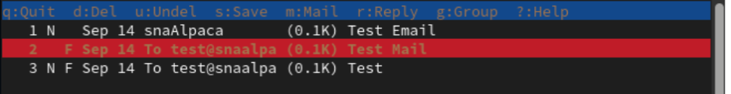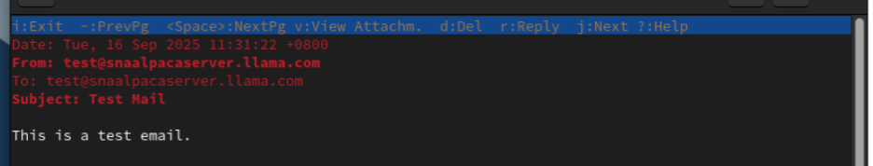

### **3.3.4 Troubleshooting**

Error: Unknown User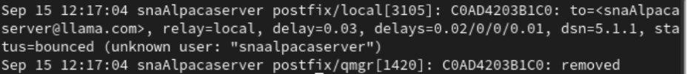

Solution

1. Create a new user with lowercase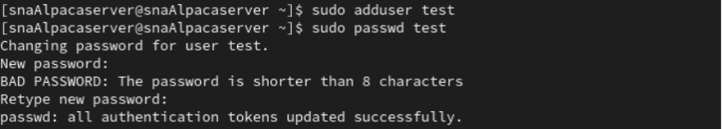
2. Use the new user for testing instead

Explanation

Postfix is case-insensitive, so it may not recognize the user. If username consists of uppercase, mails may fail to deliver.

## 3.4 SSL Configuration

SSL (Secure Sipp Layer) is a security protocol that provides encrypted communication between a server and a user that ensures the privacy and integrity of all data that is transferred between a user and a server. It is widely applied in web browsers, email and other network services to protect communications.

OpenSSL is a free software library that includes functions and tools to implement the protocols of the SSL/TLS. It is common in the generation of private keys, certificate signing requests (CSRs) generation and administration of digital certificates. OpenSSL is necessary to provide secure connection in web server, mail server and VPN.

### **3.4.1 OpenSSL Installation**

Install OpenSSL - Rocky server （SSL encrypted services)

### **3.4.2 Postfix**

Create a directory to store private keys and certificates.

Generating self-signed certificate and private key for Postfix.

Input credentials for certificates - Common Name matching server’s hostname.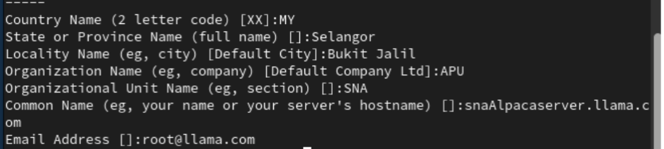

Making modifications to configuration files inside respective directories.

1. **Main.cf**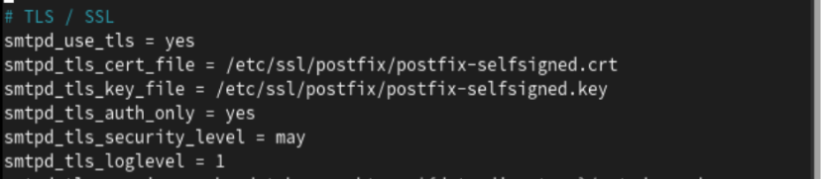Enable the TLS policies and logging activities.

Disallow TLS that are risky and only allow server to determine type of ciphers for encryption.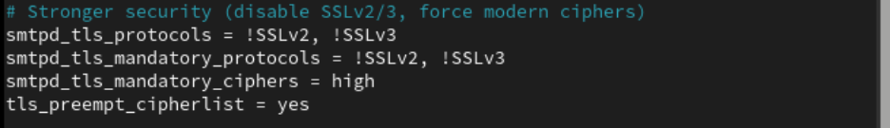

1. **Master.cf**

Configure submission service by removing the hashtags on lines. Enabling encryption on service with clients and SASL restrictions.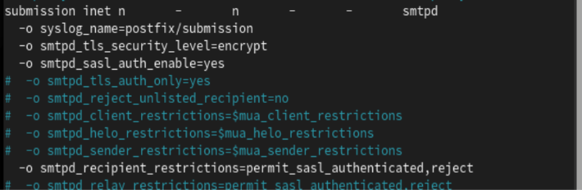

Configure legacy for the SMTPs service. Enable TLS services by removing the hashtags on lines. Enable encryption for connections between the server and client.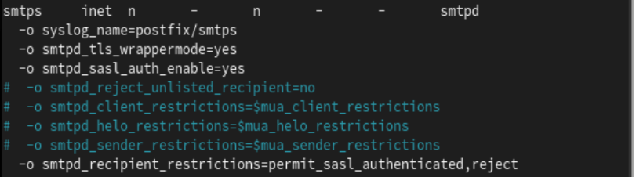

### **3.4.3 Dovecot**

Creating directory to store certificate and private key for Dovecot under /etc/ssl/.



Generate certificate and key for Dovecot.

Input credentials that are used in Postfix SSL configuration.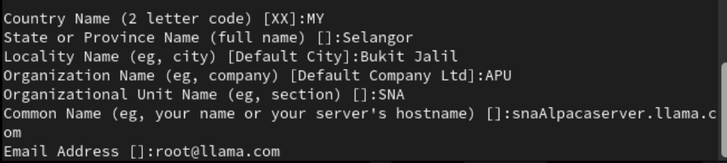

Making modifications to configure files for Dovecot (Configure SSL encryption). In 10-ssl.conf file, define location of certificate and private key.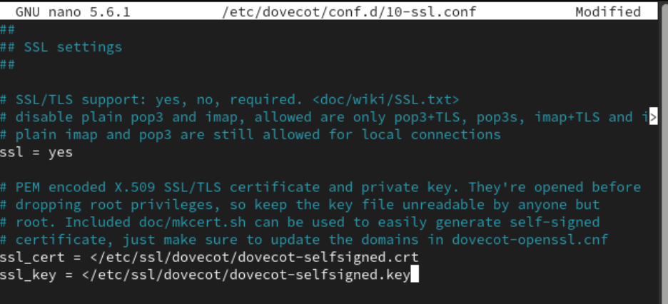

Restart services.



Adding services to firewall permanently. Reload the firewall.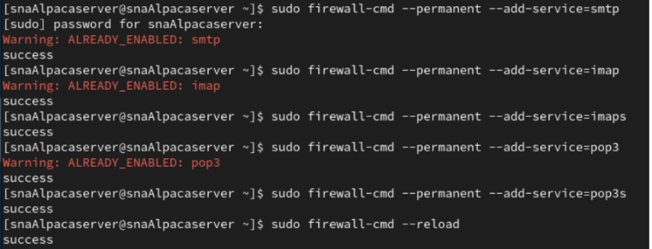

### **3.4.4 Testing SSL on Rocky Server**

Verifying SSL service on port 993 (IMAPs). The status “CONNECTED” displayed, with credentials entered earlier in the private key and certificate generation process. Certificate is self-signed; we get a verification error.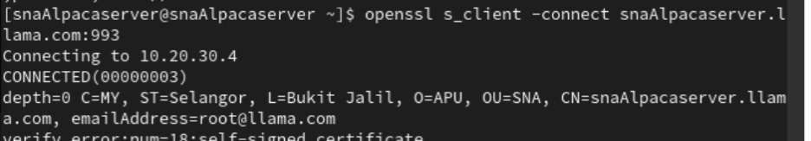

Authentication successful.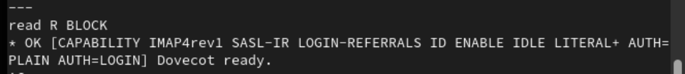

Verifying connection on port 465 for SMTPs service.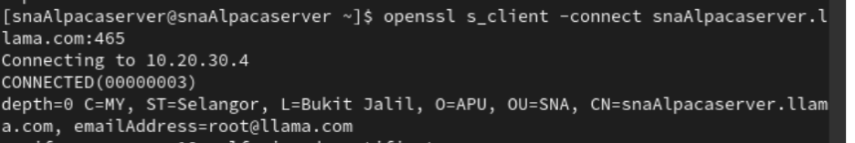

Verify the authentication: The user is authenticated.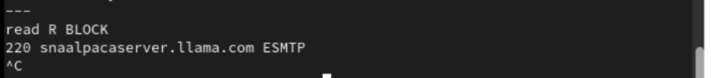

### **3.4.5 Testing SSL on Ubuntu Client**

Install OpenSSL on Ubuntu.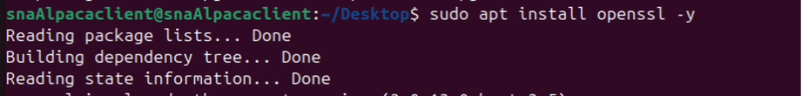

Test SMTPs service. Since the certificate is self-signed, we get verification error.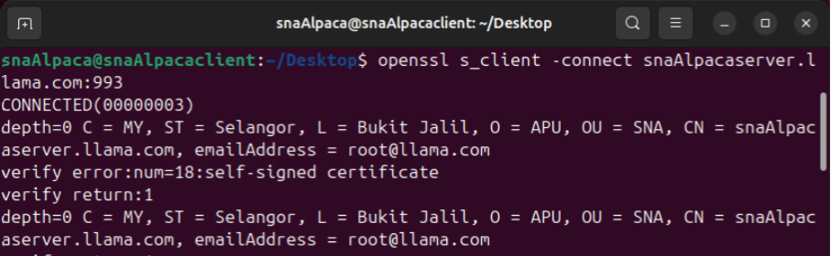

Verify authentication.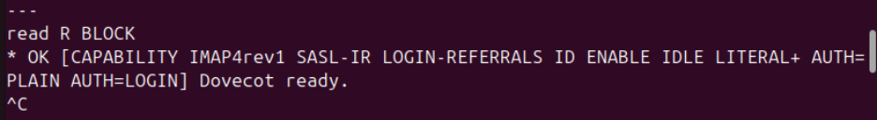

Do the same for port 465.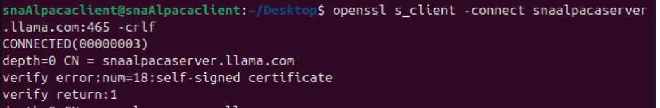

Banner configured.

## 3.5 Thunderbird

Thunderbird is an open-source email client, created by Mozilla. It enables managing numerous email accounts within the same location as well as enabling functionality such as message filtering, junk mail familiarity, encryption and extensions that are customizable. Thunderbird is also compatible with IMAP, POP3 and SMTP. Besides email, it has calendar, contact management, and chat functionality. It is a multi-purpose tool to use in both personal and professional communication.

### **3.5.1 Installation**

Install thunderbird.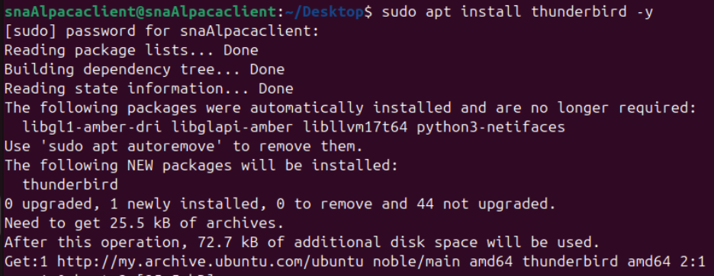

### **3.5.2 Account Setup**

Launch Thunderbird with command “thunderbird &”.

Thunderbird started successfully. We enter account name, address and password. We use an account created on Rocky server to test Mutt. The email address is username of account, followed by domain name, FQDN. The password for the account is the one we set up for the user on Rocky earlier. Then, click ‘Continue’ to configure the services.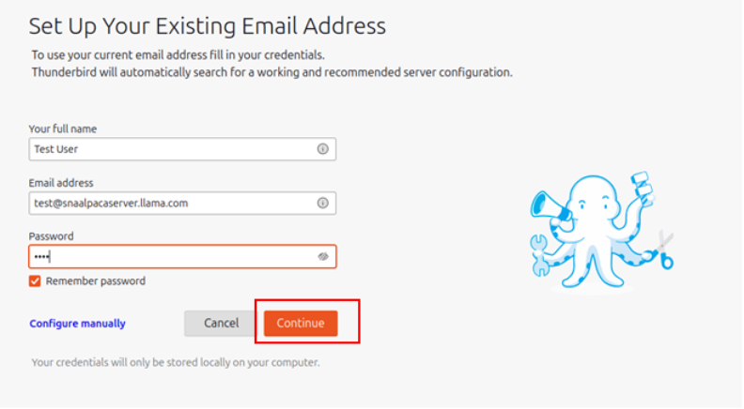

Directed to this page.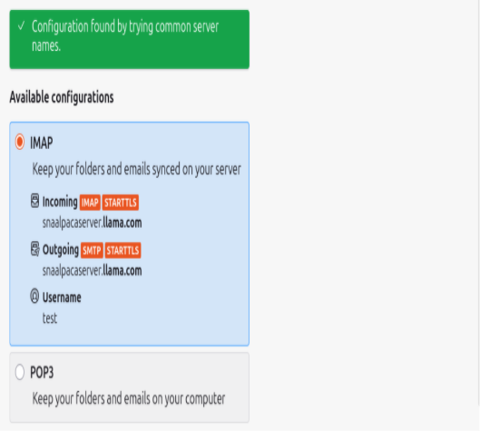

In Thunderbird we accept the initial configuration, as it doesn’t accept self-signed certificates (IP addresses circumvent verification). Connections to ports 143 and 587 use default to STARTTLS due to security, and normal password authentication due to compatibility. The error of self-signed certificates in ports 993 and 465 will cause failure, hence we modify settings after adding certificates, using the username generated on the Rocky server. 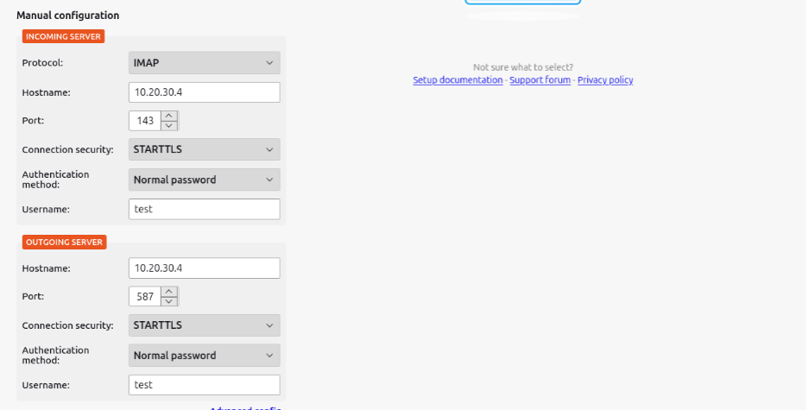

An account successfully created. We can see username and registered email address. Then, we click on **Finish.**

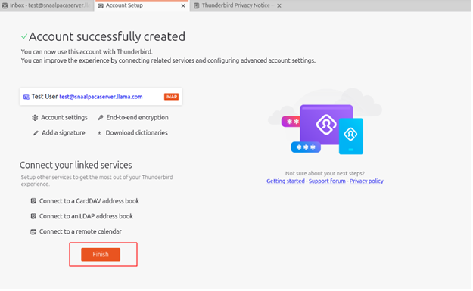

On the dashboard, we can see the previous emails sent to this account from the previous testing in Mutt.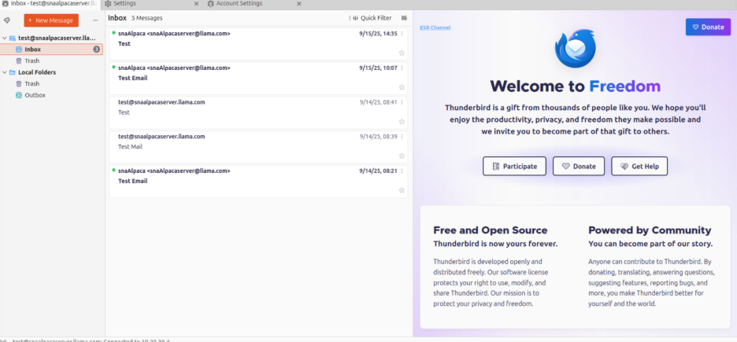

### **3.5.3 Import SSL Certificate**

Import the certificate from Rocky server into Ubuntu and to Thunderbird later. 

Importing the cert into desktop of user in Ubuntu.

Import the certificates into Thunderbird through CLI in the terminal. The text, ‘P,,’ indicates that Thunderbird is trusting the certificate.

Verify the certificates in the database. Certificates are now trusted by Thunderbird.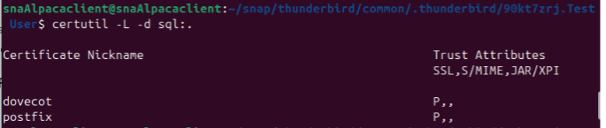

### **3.5.4 Update Configuration Settings**

In Thunderbird, under Account Settings - Server Settings / outgoing server (SMTP). In the case of IMAP, we specify port 993 for encryption and revert server name to FQDN. Turn on SSL/TLS.

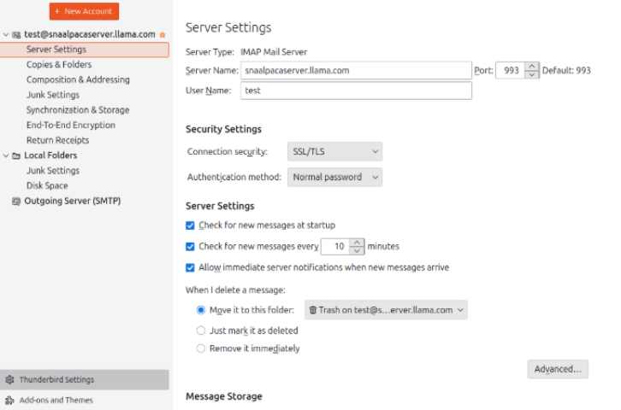

We modified the server configured and the port to 465 to secure it.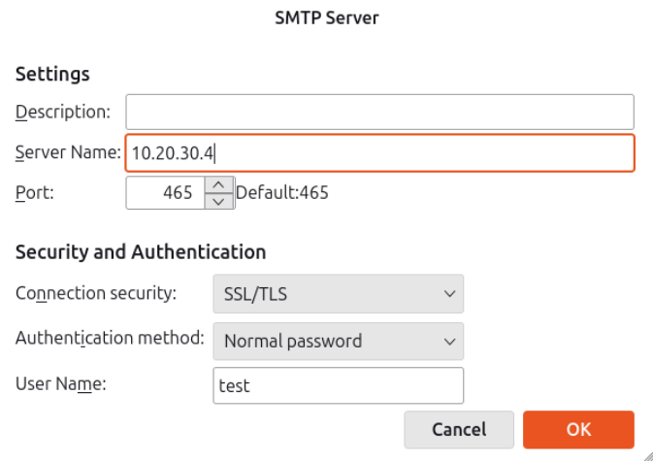

### **3.5.5 Testing with Thunderbird**

IMAPs Service Testing (Mail Receiving)

Add new user.



Login and send mail to Thunderbird.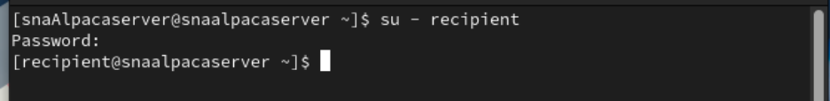

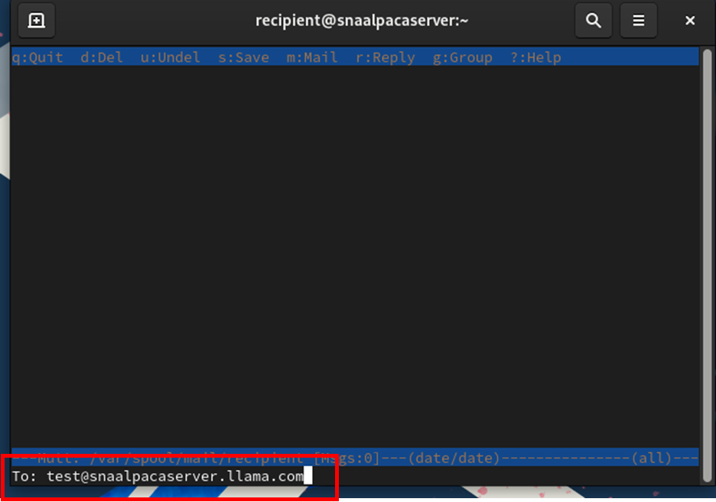

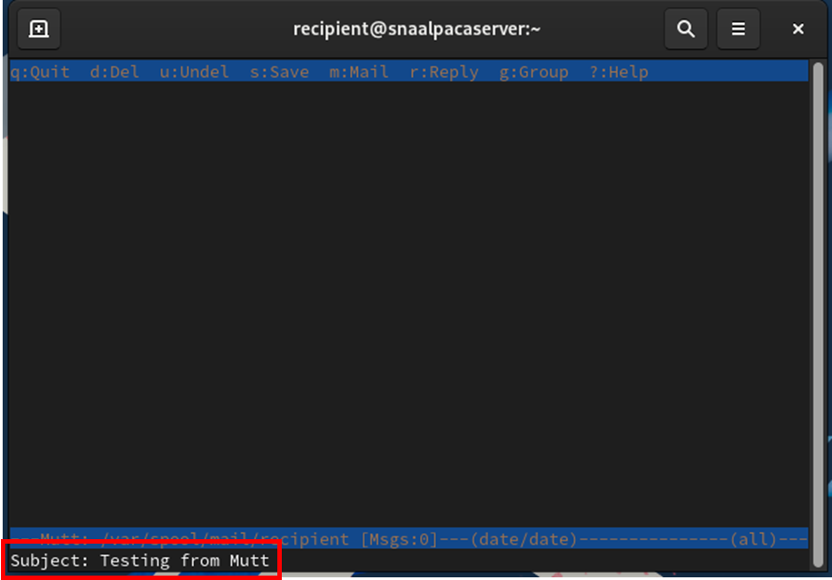

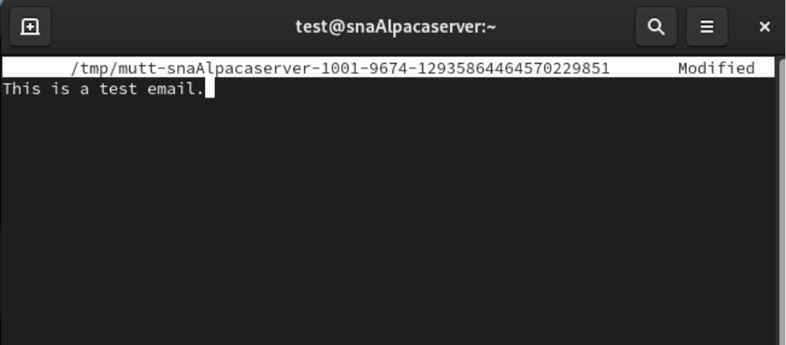

Click ‘Y’ to confirm delivery of the mail to email address we entered.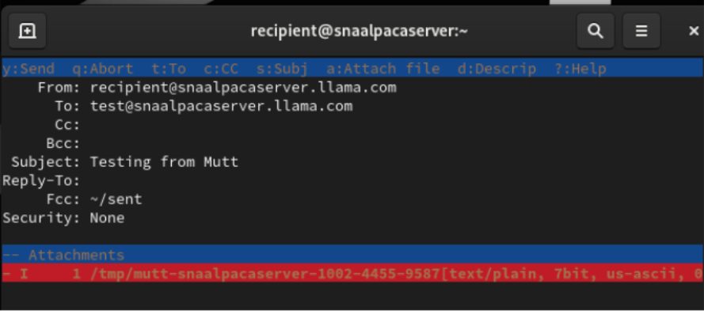

In Ubuntu, we started Thunderbird. The mail delivered from Mutt on the server has been received successfully.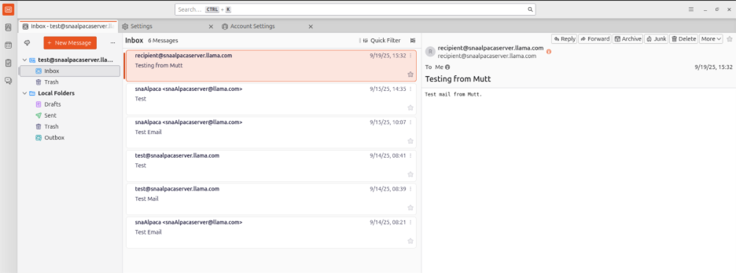

SMTPs Service Testing (Mail Sending)

Click on ‘New Message’ button to generate a new mail for testing. 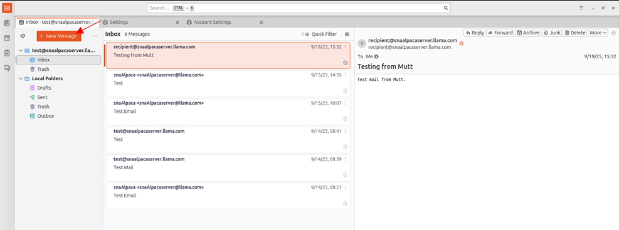

We enter the email address for the user we want as the “**recipient”**. After we constructed the mail, we send it by clicking on ‘Send’ button.

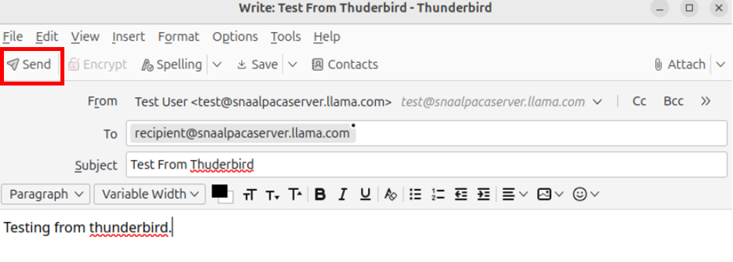

The mail is sent. Click on the Sent tab to ensure that the mail is successfully delivered.

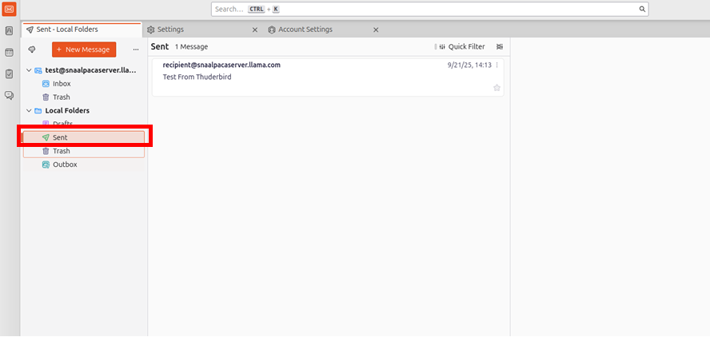

We log into the recipient’s user terminal to see all mails. By selecting email “Number 2”, email details and body will be displayed.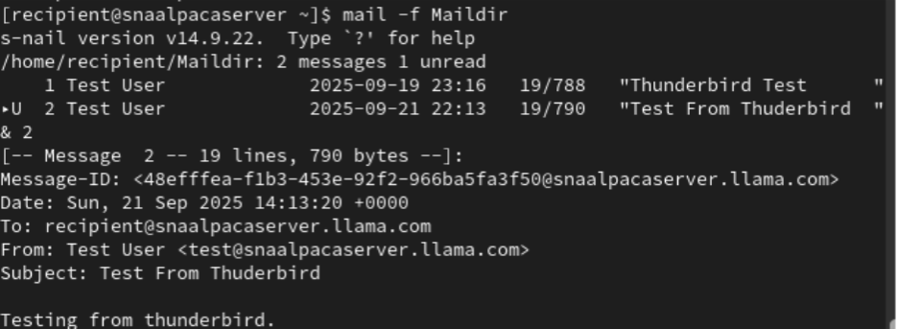

# 4.0 Web Server

The Apache HTTP Server is among the most widely utilized web servers globally. It is an open-source program compatible with any Linux server and is entirely free to install. It is utilized to manage requests and provide static or dynamic content. Its stability, versatility, and security have garnered the trust of millions of website owners, developers, and web hosting providers. I will go through the procedure for installing the Apache (httpd) server on Rocky Linux.

## 4.1 Apache Web Server

Install Apache HTTPD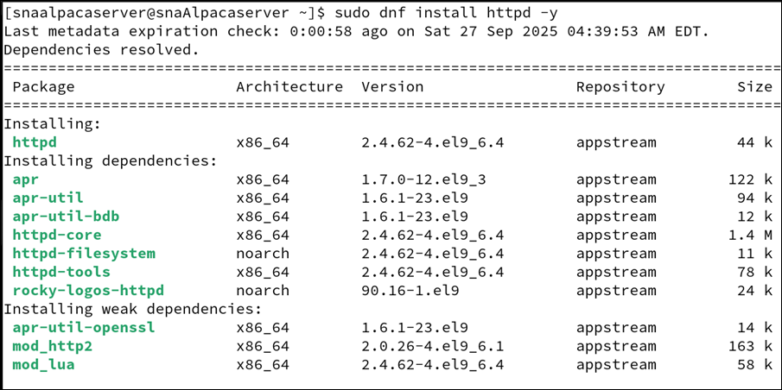

Start and Enable httpd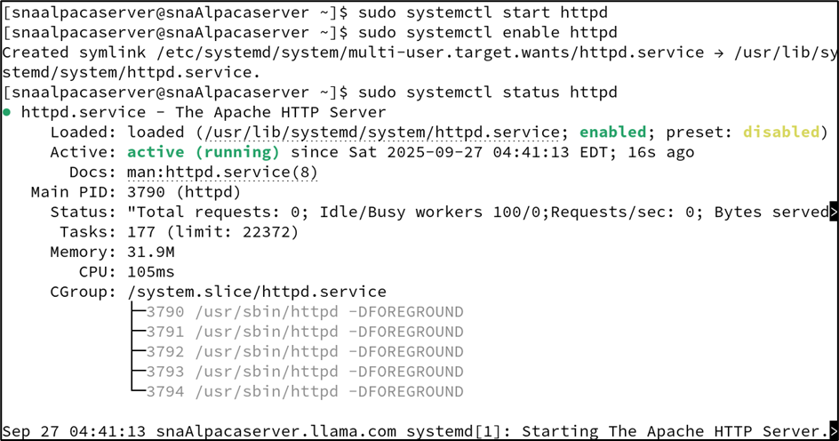

Enable firewall-cmd services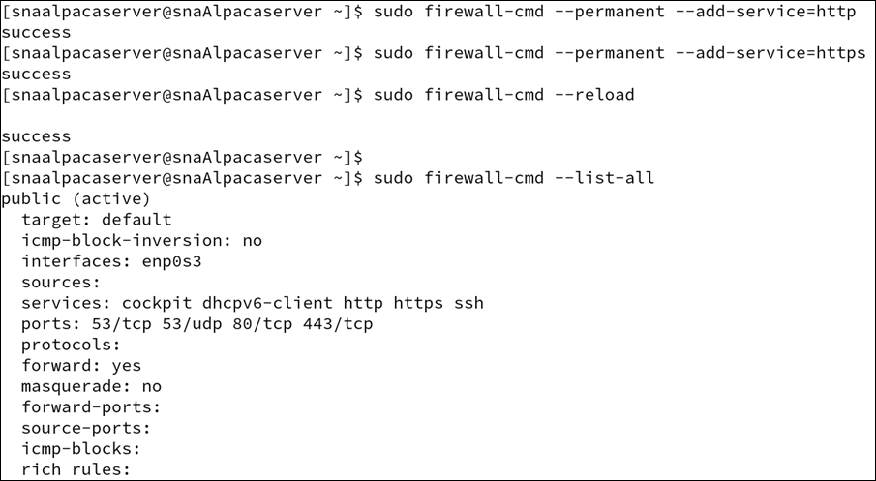

Apache HTTP Server Test Page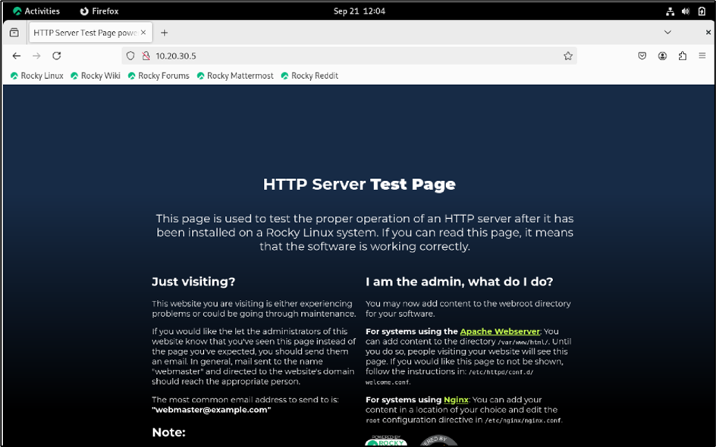

Create a Directory and HTML Index File

Configure Apache Host File 

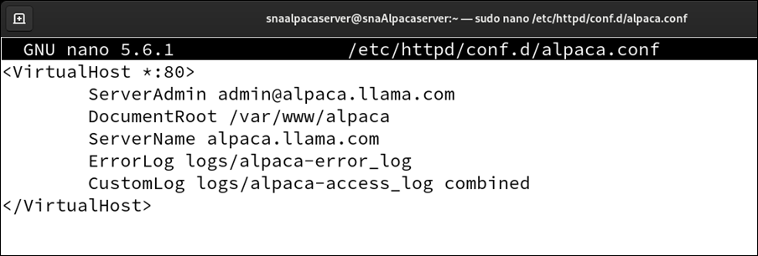

Check configuration status and restart the service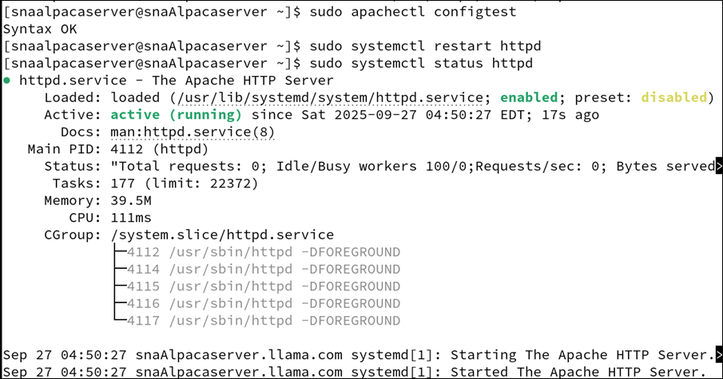

Add Hosts File

Accessed the hosts file on the Ubuntu client to associate domain names with the Apache server's IP address for local connectivity.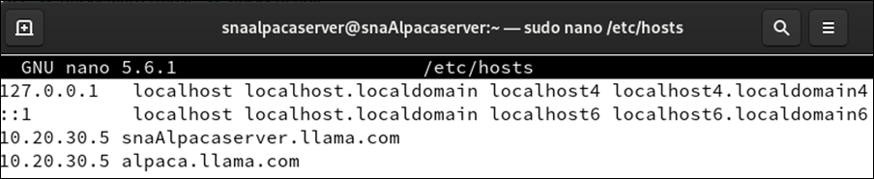

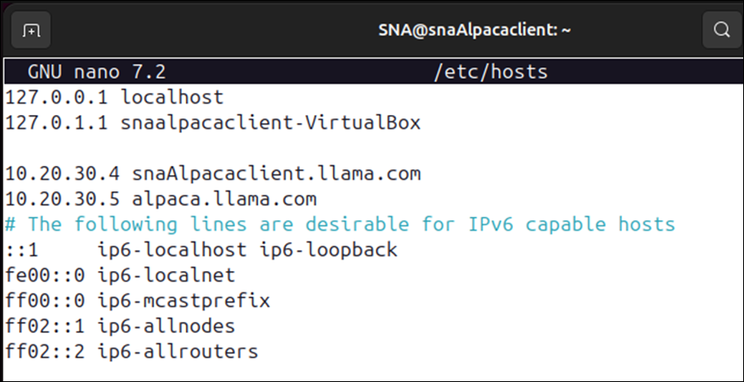

Reload Firewall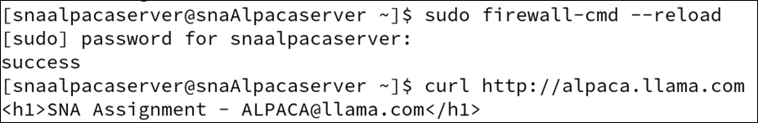

Terminal ‘curl’ web address on Rocky & Ubuntu

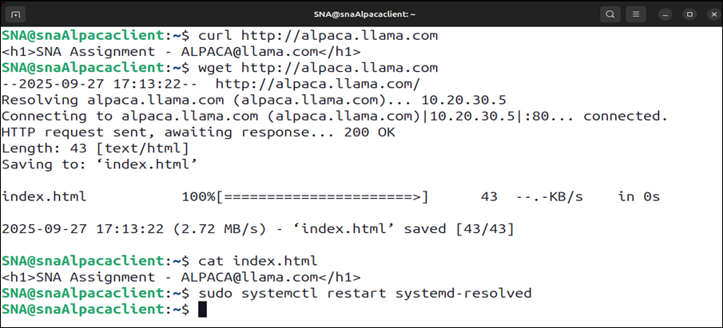

## 4.2 Installation and Configuration SSL on Apache

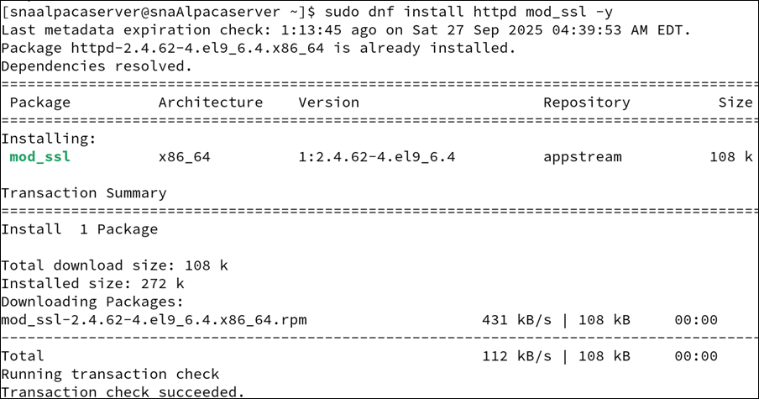

Opening SSL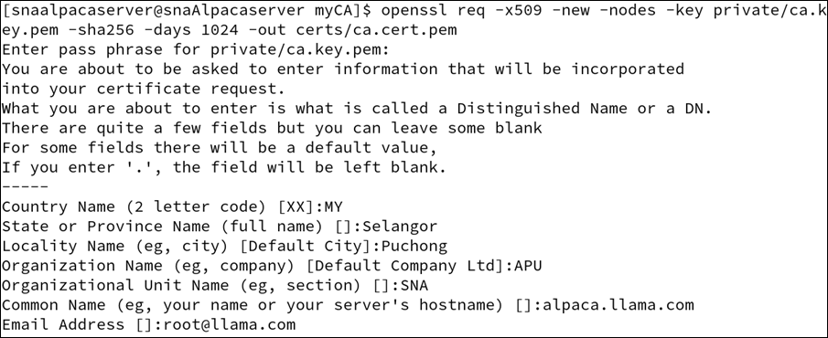

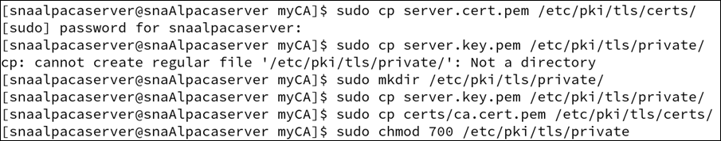



Modifying SSL Certificate Directory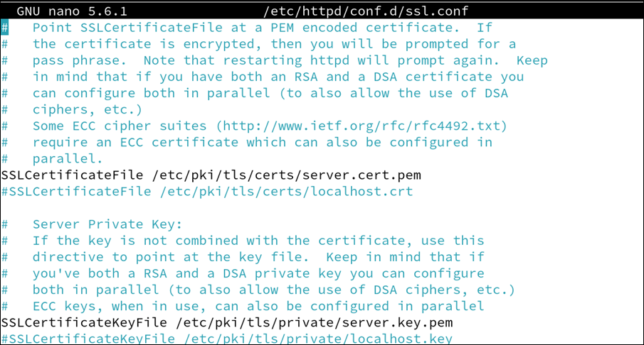

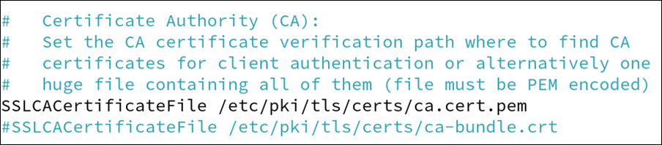

Restarting

IP address: 10.20.30.5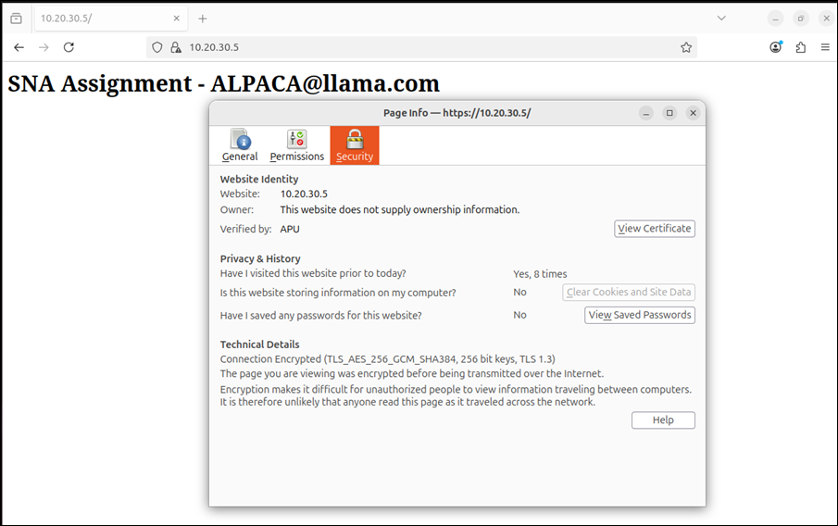

Certificate for alpaca.llama.com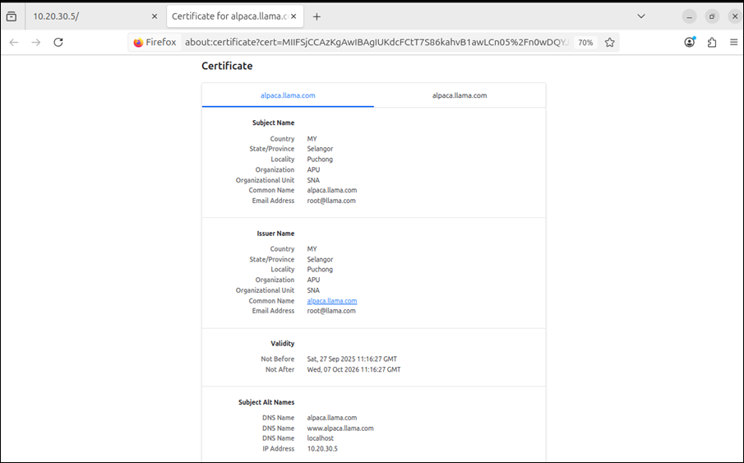

Open Browser and Access to Hostname/IP Address

Rocky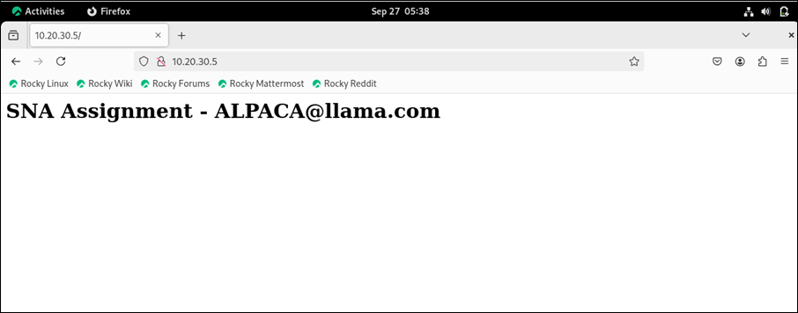

Ubuntu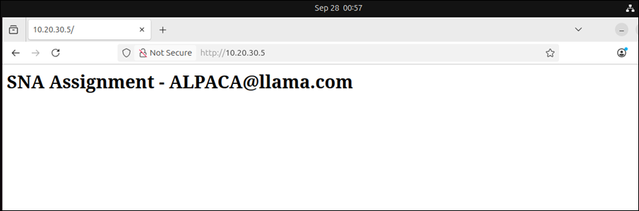

# 5.0 Extra Service

## 5.1 Fail2ban

Fail2ban is an information security tool that can assist in securing the servers against brute force attacks. It operates by analyzing logs (SSH, Apache or Postfix logs or any other logs) to identify recurring unsuccessful login attempts or suspicious traffic. Fail2ban updates the firewall rules and blocks the IP address of the attacker upon its detection to block the attacker for a specified duration of time. This will minimize the chances of unauthorized access and will assist in preventing automated attacks. It is popular due to its lightness, simplicity in set up and very effective in securing the server.

Update and upgrade Rocky system.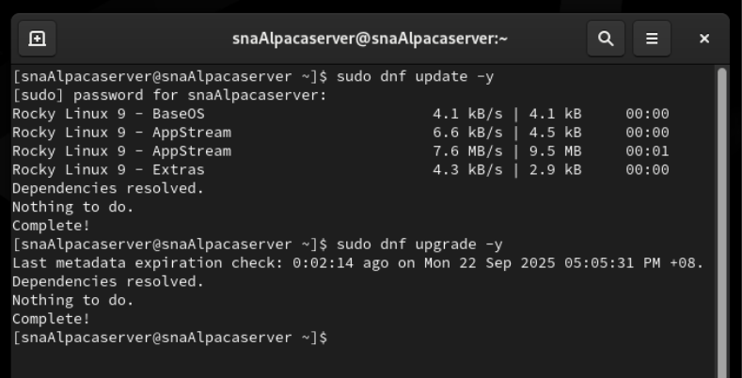

Install epel-release and enable “EPEL repository” on server. Install additional software packages that are not included in Rocky Linux repositories such as Fail2ban, HTOP.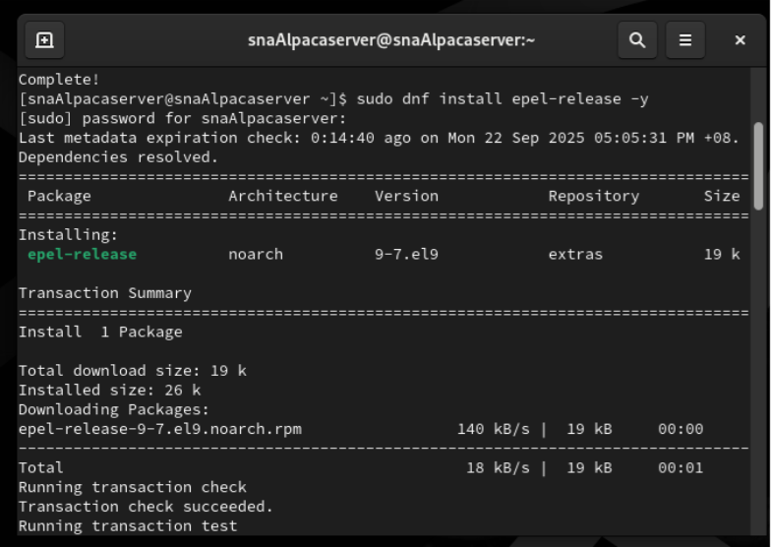

Install Fail2ban.

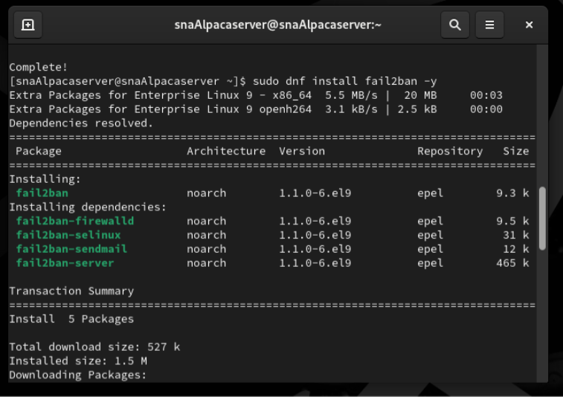

Create a copy of Fail2ban configuration file to make changes without affecting the original.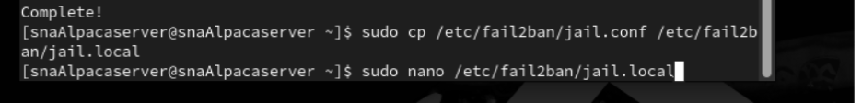

Set up the machine:

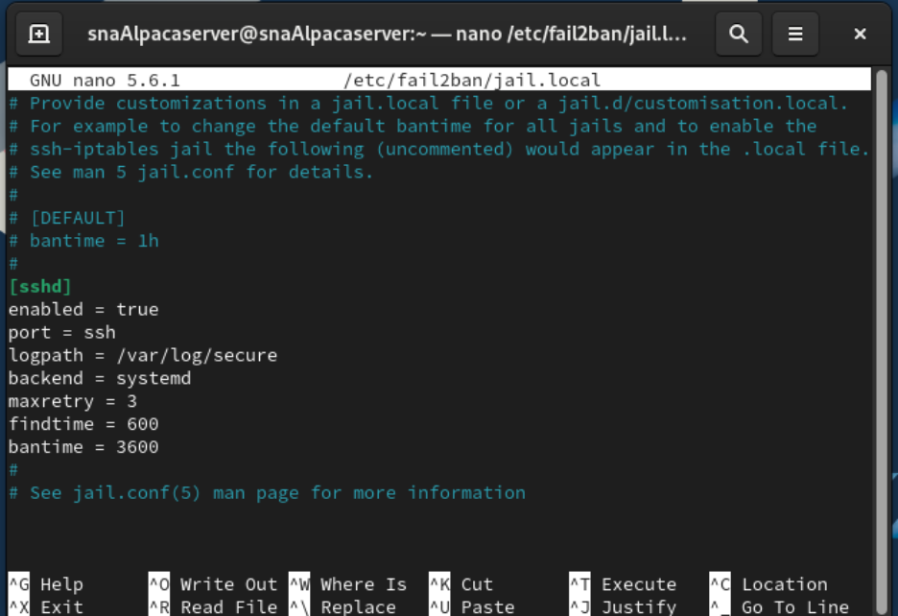

Uncomment “[sshd]” and start the jail section specifically for the SSH service.

Restart Fail2ban and check status to ensure it is running. 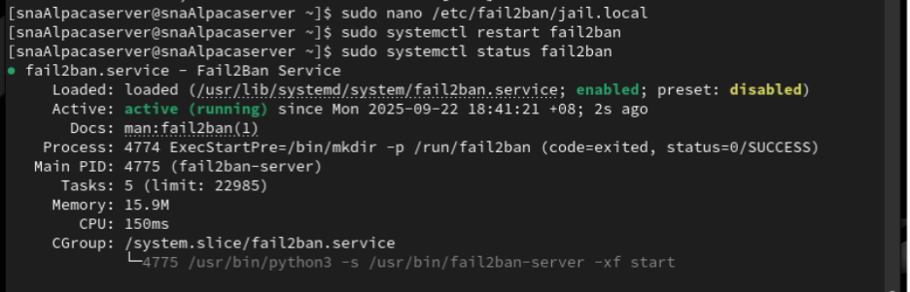

Testing:

Open Ubuntu and login server machine from client machine, with command ssh [snaAlpacaserver@10.20.30.4](mailto:snaAlpacaserver@10.20.30.4). Repeat 3 times with wrong password input.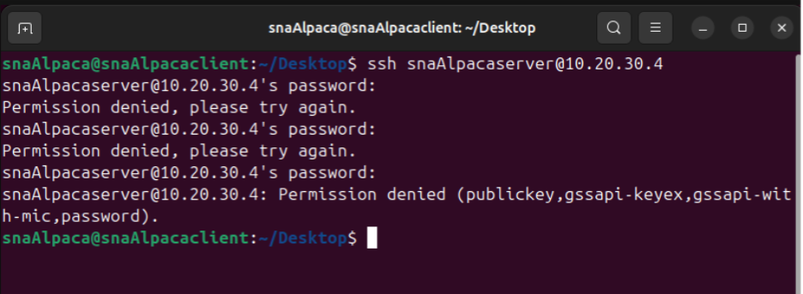

Check on server machine (Rocky) with command “sudo fail2ban-client status sshd”. To ensure there’s a record of total failed logins, the IP has been banned after 3 fail logins.

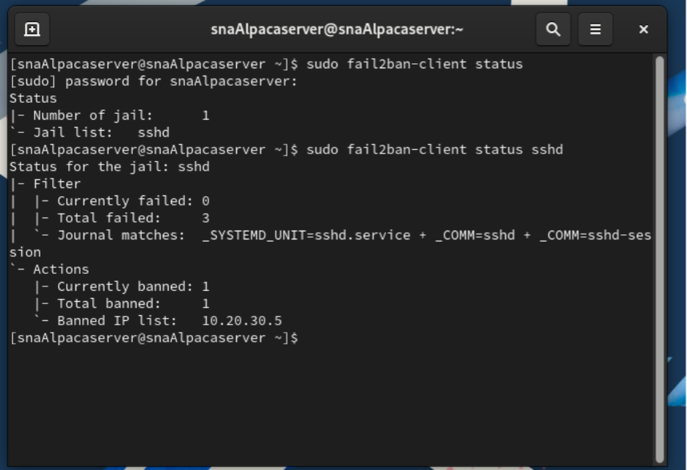

## 5.2 VPN Setup

VPN (Virtual Private Network) is a secure connection which establishes an encrypted tunnel between the device and the internet of the user. It mask IP address of the user, prevents eavesdropping of data and provides access to the private networks or restricted content through the use of the public networks.

Install epel-release.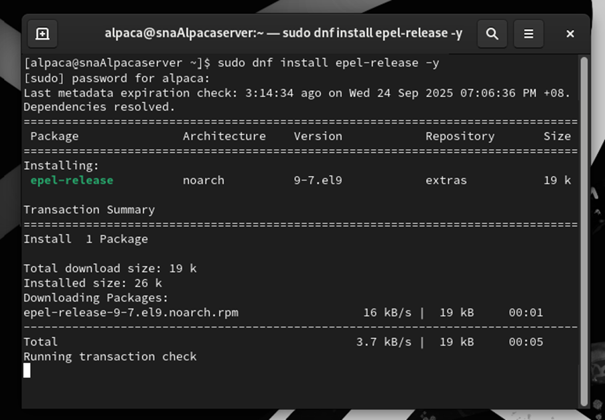

Install wireguard.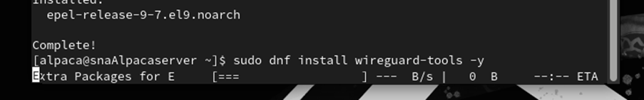

Forwarding IP (Rocky)

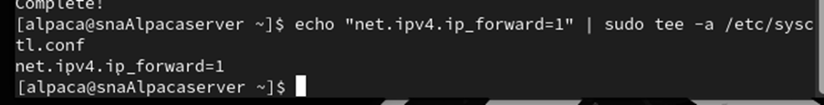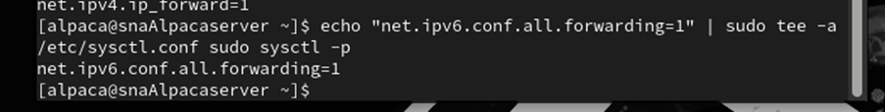

Enable IP forwarding (Ubuntu)

Creates and stores private and public keys for the WireGuard server’s secure communication.

Generate private and public key for both server and client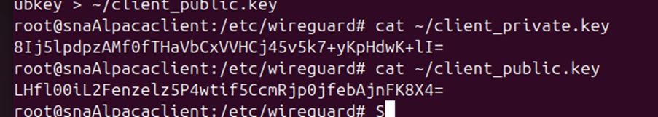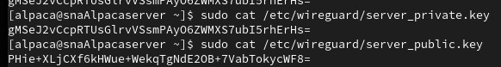

Write private and public key of both server and client

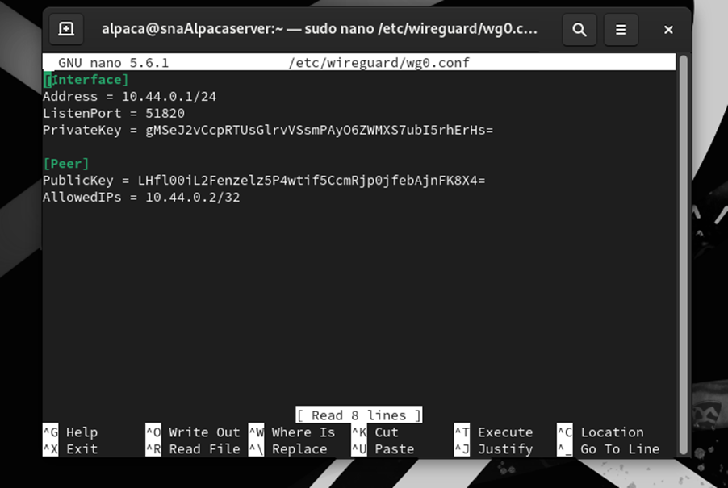

Configure VPN settings for the server



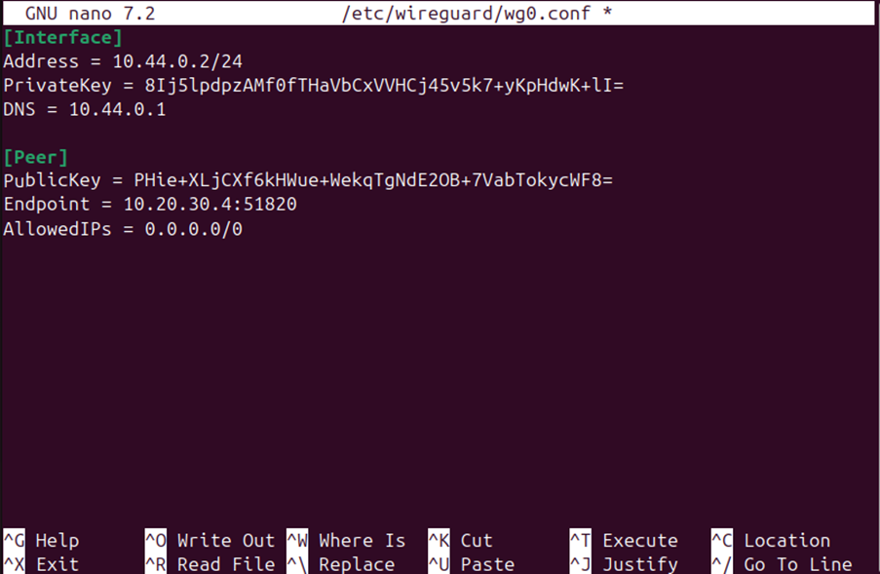

Configure VPN settings for the client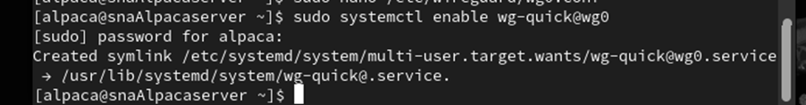

Start wireguard on server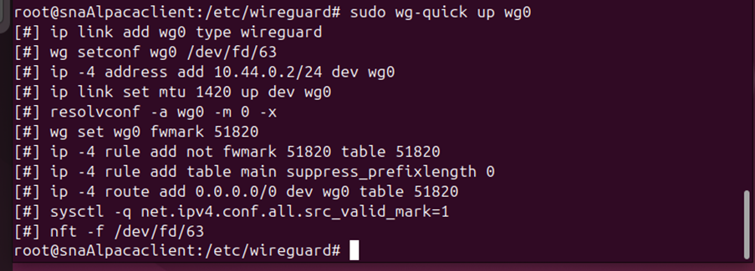

Start wireguard on client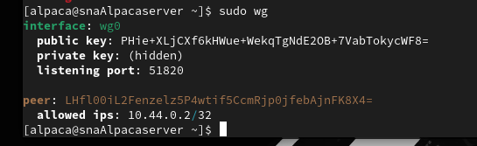

VPN display on server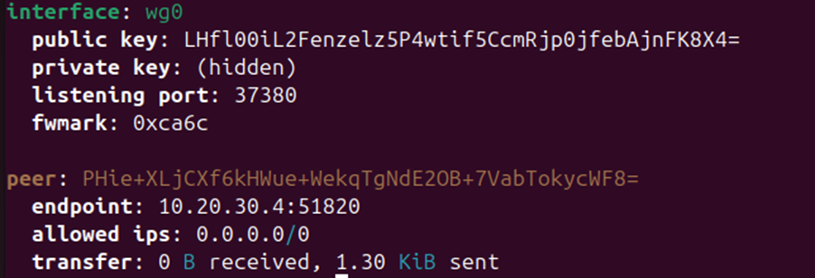

VPN display on client

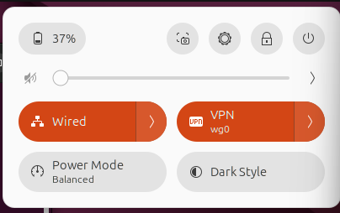

## 5.3 Lynis Audit System

Lynis is an open-source, Unix and Linux system security auditing tool. It is used to scan the system to determine security, compliance, and configuration problems. Lynis scans vulnerabilities, flawed configurations, obsolete software and unpatched systems and reports the findings in detail with advice to harden the system. It is lightweight, easy to operate, and it is common with system administrators to enhance security of the server.

Install Lynis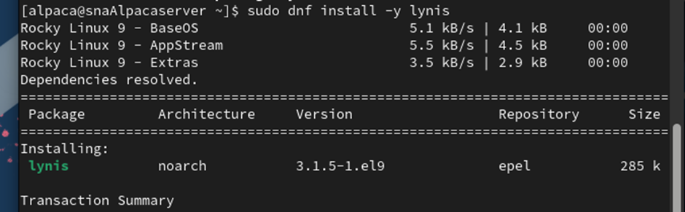

Running Lynis...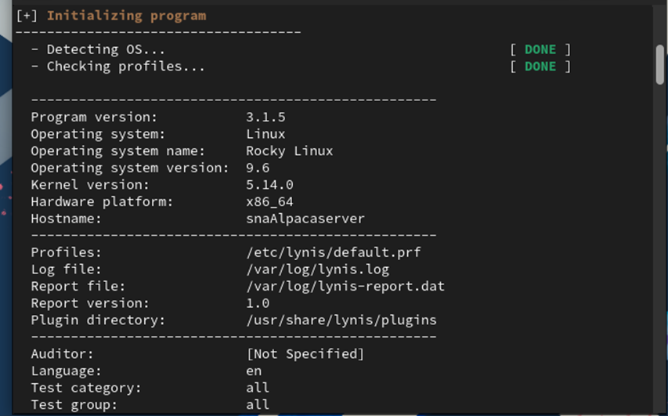

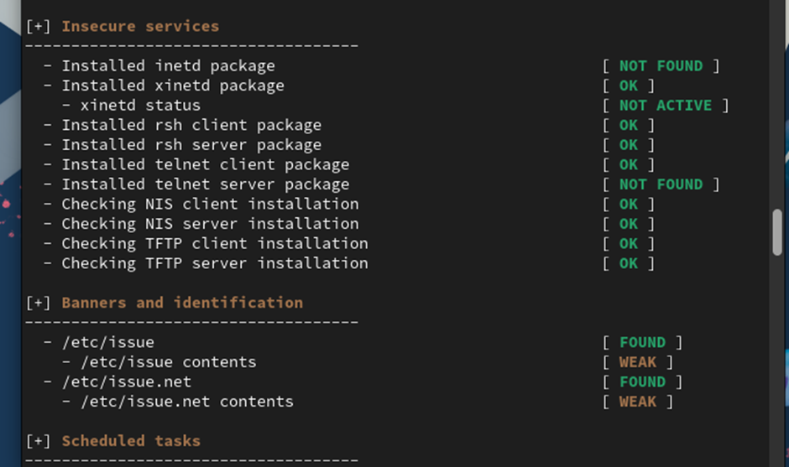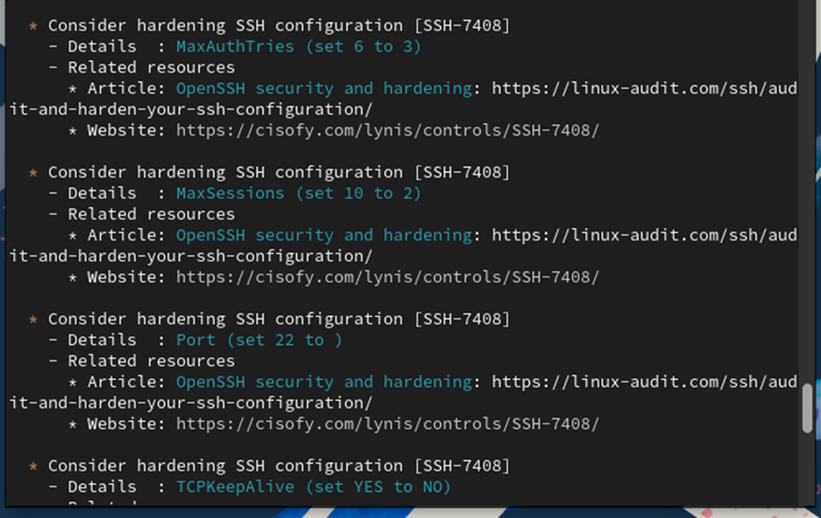

Weaknesses and vulnerabilities are found. 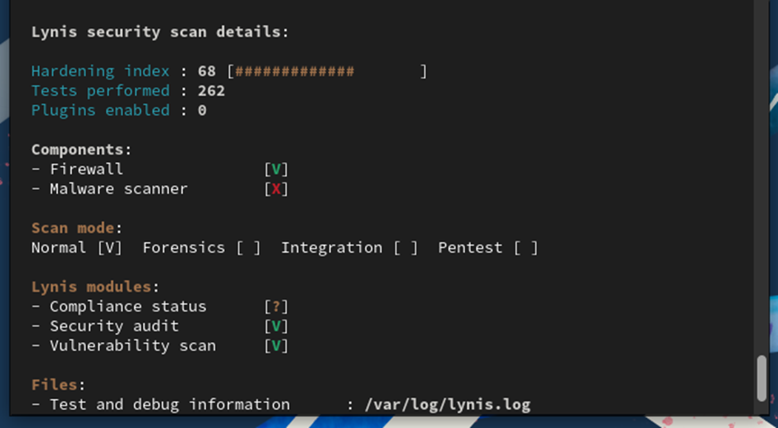

Logs displayed (/var/log/lynis.log)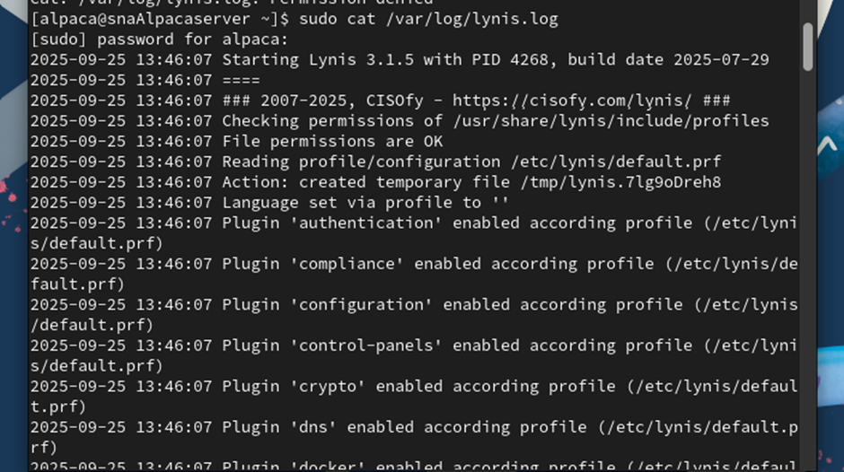

Lynis installed on Ubuntu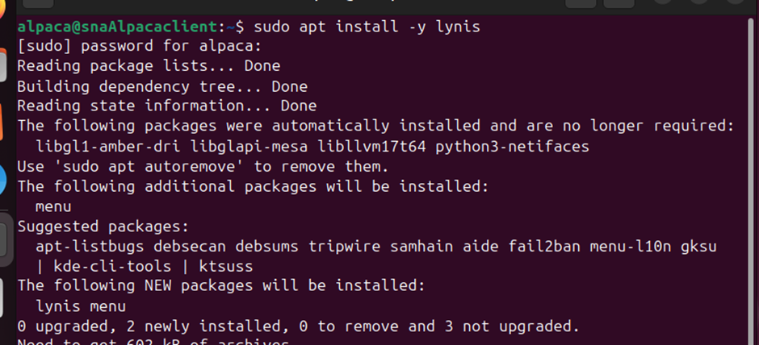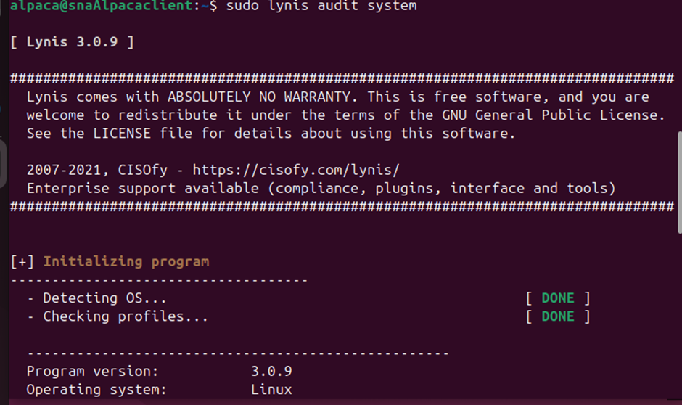

# 6.0 Troubleshooting

## 6.1 SMTP

Error 1: Thunderbird does not accept uppercase hostnames

Solution: Modify hostname.

1. **Modifying the system hostname, ensuring all the letters are lowercase.**
2. **Make changes to the DNS server configurations.**

We updated the hostname to prevent failures in service discoveries, network identity establishments and DNS resolution.

**Forward File**

Update the forward file generated during DNS configuration. Ensure both hostname in FQDN is identical to our new hostname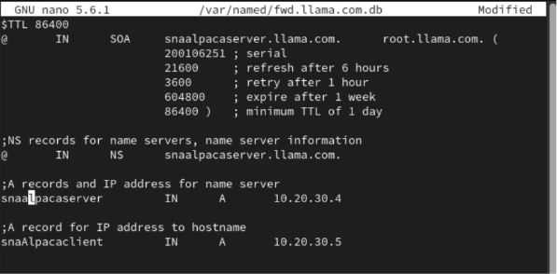

**Reverse File**

Same for the reverse file, we will modify the hostname and FQDN for our Rocky server to ensure that it matches the new hostname.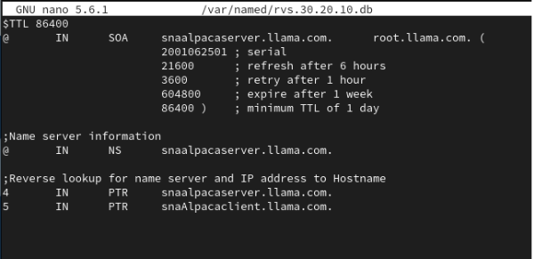

**Configuration Validation**

Verify the validity of the configurations for the service (sudo named-checkconf).

For both the forward and reverse files, verify the configurations. 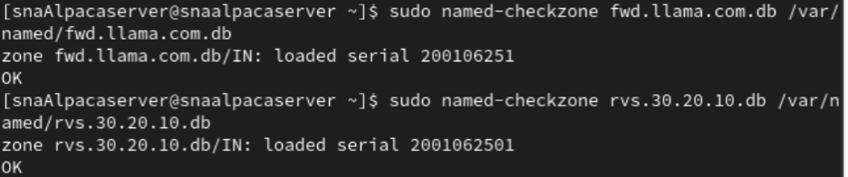

Restart the service and verify the status.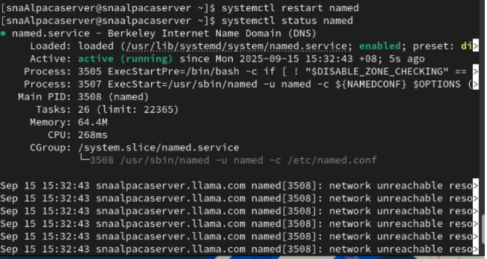

Ping test. We only ping the server and modifying the server’s hostname only.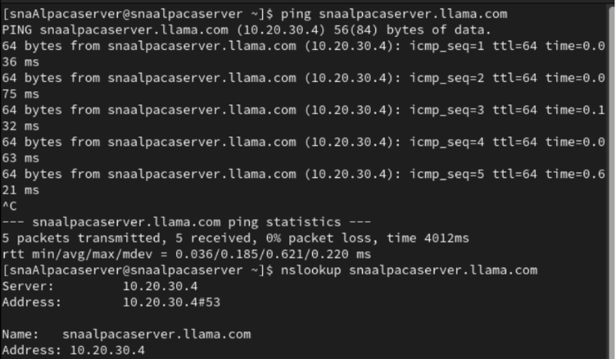

Ping test on the server’s hostname. We also use nslookup command to gain relevant information from it. 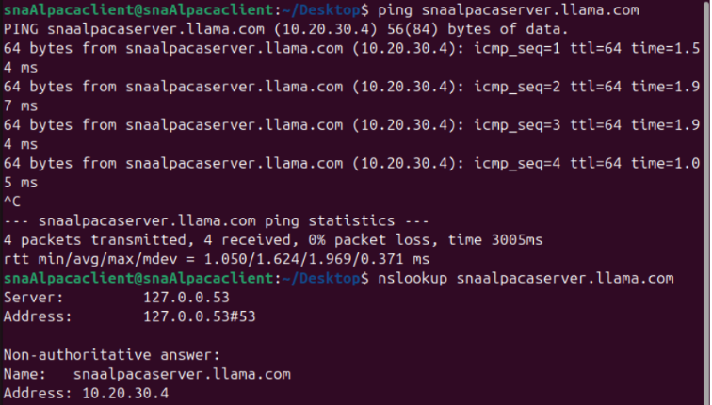

1. **After changing the hostname, we do the same for Postfix configuration files.**

main.cf

* Changed “myhostname” to new hostname in the main.cf file for postfix and restart the service.

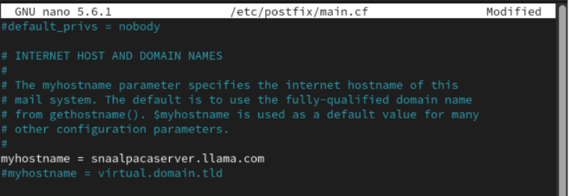

Testing locally instead of running Mutt.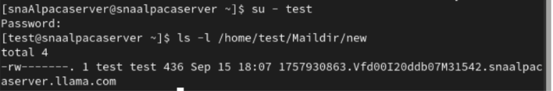

1. **Generate a new certificate and private key for Postfix.**

We generate a new certificate and private key for Postfix.

Input credentials, EXCEPT for hostname where we must input new FQDN.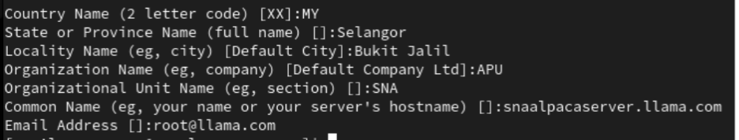

Modify the certificate and private key directory in main.cf file to ensure Postfix can locate them.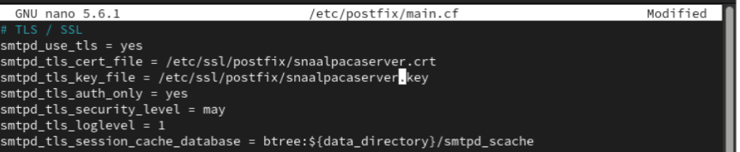

Restart the service.

We updated the ownership and permissions of the two files and set restrictions to only allow owner access.

Connection and authentication are successful.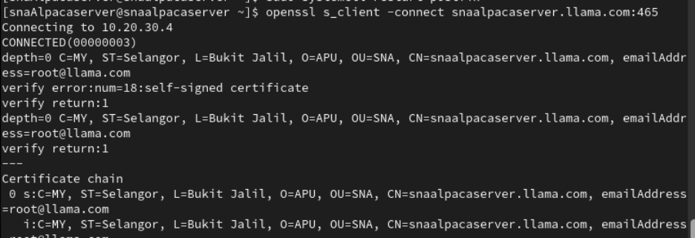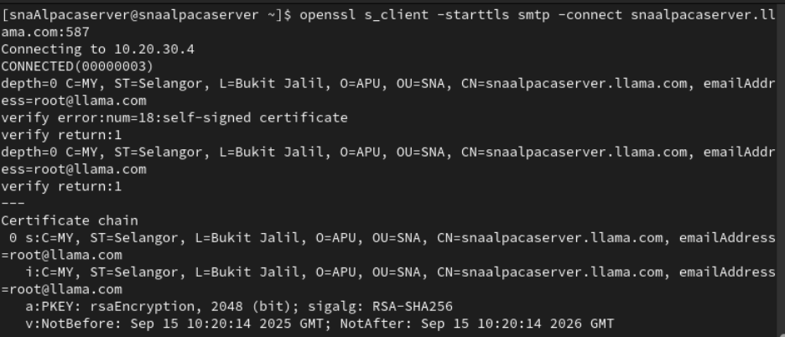

1. **Modifications on Dovecot.**

Generate new certificate and private key.

Input credentials, EXCEPT for hostname where we must input new FQDN.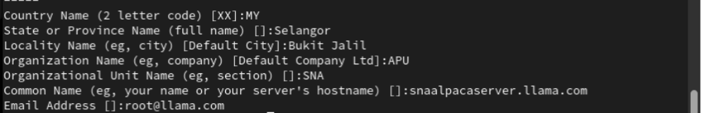

Modify configuration file, 10-ssl.conf, and update directory of certificate and key.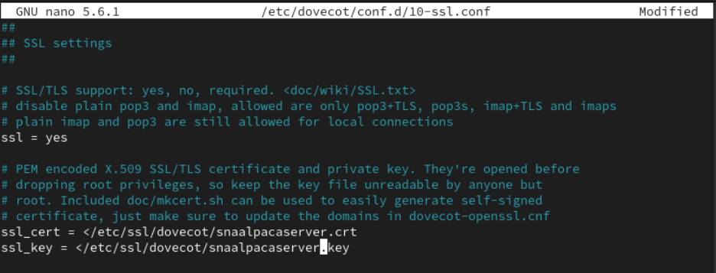

Modify ownership and permissions of both files.

Restart Dovecot.

Test SSL connection for IMAPs (port 993). Connection and authentication are successful.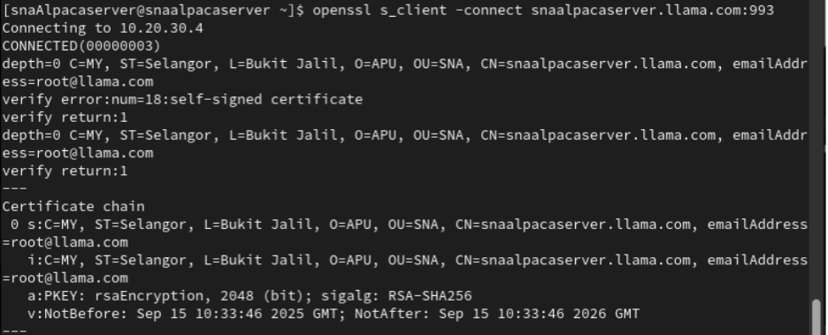

1. **OpenSSL test on Ubuntu**

Test on the client machine the ports, IMAPs (port 993) and SMTPs (port 465).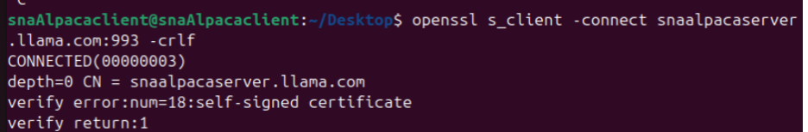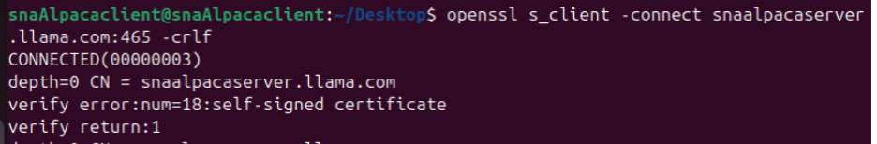

Port 993: Connection successful.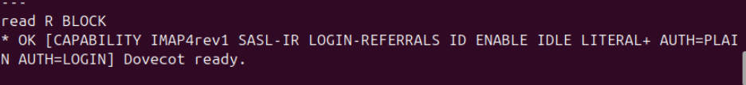

Port 465: Connection is successful.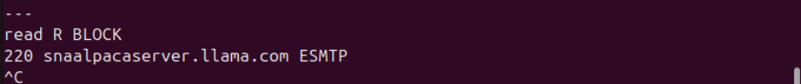

Error 2: Thunderbird authentication failure, Dovecot not listening to IMAP

Solution:

1. **Define log in is not being encrypted for compatibility.**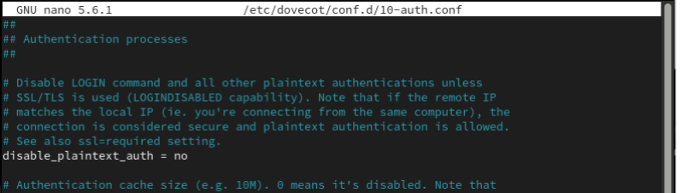
2. **Add the configuration in the file. Let Dovecot recognize the standard authentication system for Linux, PAM and using the same login mechanism as SSH.**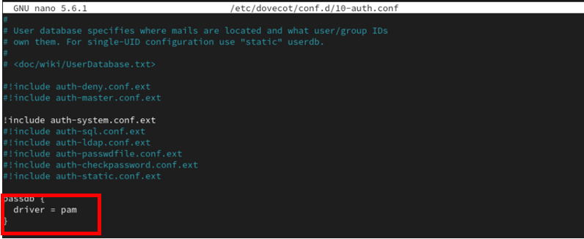

Obstacles Encountered - Unresolved Issues

**Thunderbird can't recognize the server as a trusted source for SMTPs service**

Thunderbird on Linux is buggy and doesn’t allow adding self-signed certificate exceptions via GUI.

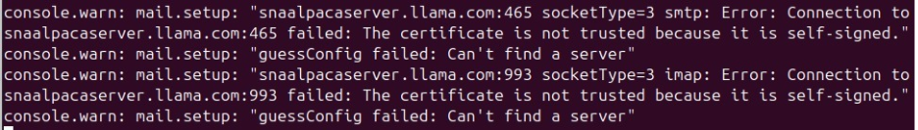

Manually edited certificate database in Thunderbird worked with IMAPs but not with SMTPs since it considered the self-signed certificates as untrusted. IMAPs linked via FQDN whereas SMTPs could only connect via IP address to bypass verification.

## 6.2 Apache Web Server

Rocky and Ubuntu Firefox Browser browse hostname unsuccessful but can browse in IP Address ‘10.20.30.5’.

Unable to connect 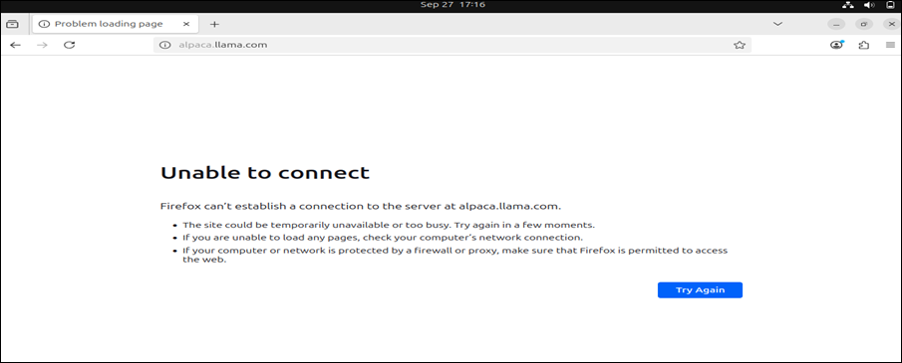

IP address: 10.20.30.5

Certificate for alpaca.llama.com

Troubleshooting: 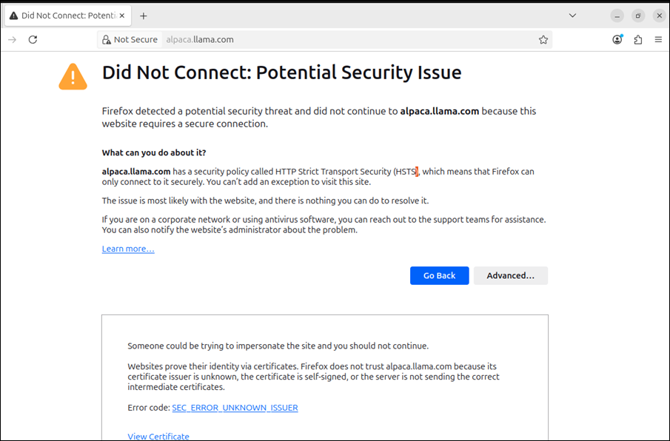

Browse hostname on Ubuntu show potential security issue. Browse with IP address will be successfully access.

# 7.0 Conclusion

During this assignment, we were able to configure and integrate a variety of services to create a secure and working mail and server environment. Dovecot was configured to allow IMAP/POP3 access and Thunderbird and Mutt were used as clients. Apache offered web services and Lynis was implemented to scan the security of the system and indicate the points that have to be improved. The protection against brute force attacks was installed with the help of fails2ban, and remote connectivity was also secured with VPN. These tools combined enhanced usability as well as security providing a well-built and well-guarded server environment.

# 8.0 Group Photo

# 9.0 References

1. LinuxBabe. (2022, September 4). Install Dovecot IMAP server on Rocky Linux 9 / Alma Linux 9 & enable TLS encryption. LinuxBabe. Retrieved from

<https://www.linuxbabe.com/redhat/install-dovecot-imap-server-rocky-linux-9-alma-linux-9>

1. Devtutorial. (2025, March 27). How to install and configure Postfix on Rocky Linux 9. Devtutorial. Retrieved from [https://devtutorial.io/how-to-install-and-configure-postfix-on-rocky-linux-9-p3387.html devtutorial.io](https://devtutorial.io/how-to-install-and-configure-postfix-on-rocky-linux-9-p3387.html%20devtutorial.io)
2. DebugPoint. (n.d.). Set up Thunderbird email Ubuntu. Retrieved from <https://www.debugpoint.com/set-up-thunderbird-email-ubuntu/>
3. The Linux Code. (n.d.). Install Thunderbird Ubuntu 22.04. Retrieved from <https://thelinuxcode.com/install-thunderbird-ubuntu-22-04/>